**The exam has the following content domains and weightings:**

• Domain 1: Cloud Concepts (24% of scored content)

• Domain 2: Security and Compliance (30% of scored content)

• Domain 3: Cloud Technology and Services (34% of scored content)

• Domain 4: Billing, Pricing, and Support (12% of scored content)

# Module 1 Introduction

**1-1. Deployment models for cloud computing**

1) CLOUD-BASED DEPLOYMENTON

2) ON-PREMISES DEPLOYMENT

3) HYBRID DEPLOYMENT

**1-2. Benefits of cloud computing**

1) Trade upfront expense for variable expense

2) Stop spending money to run and maintain data centers

3) Stop guessing capacity

4) Benefit from massive economies of scale

5) Increase speed and agility

6) Go global in minutes

# Module 2 Compute in the Cloud

**2-1. Amazon EC2 instance types**

**1) General purpose instances**

**2) Compute optimized instances**

**3) Memory optimized instances**

**4) Accelerated computing instances**

**5) Storage optimized instances**

2-2 Amazon EC2 Pricing

1) **On-Demand Instances**

2) **EC2 Instance Savings Plans**

3) Reserved Instances

3-1) Standard Reserved Instances

3-2) Convertible Reserved Instances

4) Spot Instances

**5) Dedicated Hosts**

2-3. Scalability

**1) Amazon EC2 Auto Scaling**

# 2-4. Directing Traffic with Elastic Load Balancing

# 2-5. Messaging and Queuing

**1) Monolithic applications and microservices**

**2) Amazon Simple Notification Service (Amazon SNS)**

**3) Amazon Simple Queue Service (Amazon SQS)**

# 2-6. Additional Compute Services

**Serverless computing**

**1) AWS Lambda**

**2) Containers**

**2-1) Amazon Elastic Container Service (Amazon ECS)**

**2-2) Amazon Elastic Kubernetes Service (Amazon EKS)**

**2-3) AWS Fargate**

# Module 3 Global Infrastructure and Reliability

**3-1. Selecting a Region**

1) Compliance with data governance and legal requirements

2) Proximity to your customers

3)Available services within a Region

4) Pricing

**3-2. Availability Zones (zone은 data center 단위, zone이 모이면 region)**

# 3-3. Edge Locations

# 3-4. How to Provision AWS Resources

# **1) Ways to interact with AWS services**

# 1-1) The AWS Management Console

1-2) **AWS Command Line Interface (AWS CLI)**

1-3) **software development kits (SDKs)**

2) AWS Elastic Beanstalk

3) AWS CloudFormation

# 4) AWS Outposts Family overview

# Module 4 Networking

# 4-1. Connectivity to AWS

**1) Amazon Virtual Private Cloud (Amazon VPC)**

**2) Internet gateway**

**3) Virtual private gateway**

**4) AWS Direct Connect**

# 4-2. Subnets and Network Access Control Lists

**1) Subnets**

**2) Network traffic in a VPC**

**3) Network ACLs**

**4) Stateless packet filtering**

5) Security groups

**6) Stateful packet filtering**

**7) VPC component recall**

# 4-3. Global Networking

**1) Amazon Route 53**

# Module 5 Storage and Databases

# 5-1. Instance Stores and Amazon Elastic Block Store (Amazon EBS)

**Instance stores**: Block-level storage volumes behave like physical hard drives.

1) instance store

2) Amazon Elastic Block Store (Amazon EBS)

# 5-2. Amazon Simple Storage Service (Amazon S3)

**1) Amazon S3 storage classes**

1-1) S3 Standard

1-2) S3 Standard-Infrequent Access (S3 Standard-IA)

1-3) S3 One Zone-Infrequent Access (S3 One Zone-IA)

1-4) S3 Intelligent-Tiering (접근 많이 안 하면 자동으로 tier를 바꿔서 돈을 세이브함)

1-5) S3 Glacier Instant Retrieval

1-6) S3 Glacier Flexible Retrieval

1-7) S3 Glacier Deep Archive

1-8) S3 Outposts

# **2) Comparing Amazon EBS and Amazon S3**

# 5-3. Amazon Elastic File System (Amazon EFS)

**1) File storage**

**2) Comparing Amazon EBS and Amazon EFS**

**5-4. Amazon Relational database Service**

**1) Relational databases**

**2)Amazon Relational Database Service**

**3) Amazon RDS database engines**

**4) Amazon Aurora**

# 5-5. Amazon DynamoDB

**1) Nonrelational databases**

**2) Amazon DynamoDB**

# 5-6. Amazon Redshift

# 5-7. AWS Database Migration Service

**1) AWS Database Migration Service (AWS DMS)**

**2) Other use cases for AWS DMS**

# 5-8. Additional Database Services

1) Amazon DocumentDB

2) Amazon Neptune

3) Amazon Quantum Ledger Database (Amazon QLDB)

4) Amazon Managed Blockchain

5) Amazon ElastiCache

6) Amazon DynamoDB Accelerator (DAX)

# Module 6 Security

# 6-1. AWS Shared Responsibility Model

**1) The AWS shared responsibility model**

# 6-2 User Permissions and Access

**1) AWS Identity and Access Management (IAM)**

**2) AWS account root user**

**3) IAM users**

**4) IAM policies**

**5) IAM groups**

**6) IAM roles**

**7) Multi-factor authentication**

# 6-3. AWS Organizations

**1) AWS Organizations**

**2) Organizational units**

# 6-4 Compliance

**1) AWS Artifact**

1-1) AWS Artifact Agreements

1-2) AWS Artifact Reports

**2) Customer Compliance Center**

# 6-5 Denial-of-Service Attacks

**1) Denial-of-service attacks (DoS)**

**2) Distributed denial-of-service attacks (DDoS)**

**3) AWS Shield**

3-1) AWS Shield Standard

3-2) AWS Shield Advanced

# 6-6 Additional Security Services

**1) AWS Key Management Service (AWS KMS)**

**2) AWS WAF**

**3) Amazon Inspector (pin test)**

**4) Amazon GuardDuty**

# Module 7 Monitoring and Analytics

# 7-1. Amazon CloudWatch

**1) Amazon CloudWatch**

**2) CloudWatch alarms**

**3) CloudWatch dashboard**

# 7-2. AWS CloudTrail

**1) AWS CloudTrail**

# 7-3. AWS Trusted Advisor

**1) AWS Trusted Advisor**

**2) AWS Trusted Advisor dashboard**

# Module 8 Pricing and Support

# 8-1. AWS Free Tier

1) Always Free

2) 12 Months Free

3) Trials

# 8-2. AWS Pricing Concepts

**1) How AWS pricing works**

Pay for what you use.

Pay less when you reserve.

Pay less with volume-based discounts when you use more.

**2) AWS Pricing Calculator**

**3) AWS pricing examples**

**3-1) AWS Lambda**

**3-2) Amazon EC2**

**3-3) Amazon S3**

# 8-3. Billing Dashboard

# 8-4. Consolidated Billing

# 8-5. AWS Budgets

# 8-6. AWS Cost Explorer

# 8-7. AWS Support Plans

**1) AWS Support**

**1-1) Basic Support**

1-2) Developer Support

1-3) Business Support

1-4) Enterprise On-Ramp Support

1-5) Enterprise Support

**2) Technical Account Manager (TAM)**

# 8-8. AWS Marketplace

# Module 9 Migration and Innovation

# 9-1. AWS Cloud Adoption Framework (AWS CAF)

1) Business Perspective

2) People Perspective

3) Governance Perspective

4) Platform Perspective

5) Security Perspective

6) Operations Perspective

**9-2. 6 strategies for migration**

1) Rehosting

2) Replatforming

3) Refactoring/re-architecting

4) Repurchasing

5) Retaining

6) Retiring

# 9-3. AWS Snow Family

1) AWS SNOWCONE

2) AWS SNOWBALL

3) AWS SNOWMOBILE

# 9-4. Innovation with AWS

**9-1) Innovate with AWS Services**

1) Serverless applications

2) Machine learning

3) Artificial intelligence

* Get code recommendations while writing code and identify security issues in your code with Amazon CodeWhisperer.
* Convert speech to text with Amazon Transcribe.
* Discover patterns in text with Amazon Comprehend.
* Identify potentially fraudulent online activities with Amazon Fraud Detector.
* Build voice and text chatbots with Amazon Lex.

# Module 10 The Cloud Journey

# 10-1. The AWS Well-Architected Framework

1) Operational excellence

2) Security

3) Reliability

4) Performance efficiency

5) Cost optimization

6) Sustainability

# 10-2. Benefits of the AWS Cloud

**Advantages of cloud computing**

1) Trade upfront expense for variable expense.

2) Benefit from massive economies of scale.

3) Stop guessing capacity.

4) Increase speed and agility.

5) Stop spending money running and maintaining data centers.

6) Go global in minutes.

# Module 1 Introduction

**1-1. Deployment models for cloud computing**

When selecting a cloud strategy, a company must consider factors such as required cloud application components, preferred resource management tools, and any legacy IT infrastructure requirements.

The three cloud computing deployment models are cloud-based, on-premises, and hybrid.

To learn more about deployment models, choose each of the following three tabs.

1) CLOUD-BASED DEPLOYMENTON

* Run all parts of the application in the cloud.
* Migrate existing applications to the cloud.
* Design and build new applications in the cloud.

In a **cloud-based deployment** model, you can migrate existing applications to the cloud, or you can design and build new applications in the cloud. You can build those applications on low-level infrastructure that requires your IT staff to manage them. Alternatively, you can build them using higher-level services that reduce the management, architecting, and scaling requirements of the core infrastructure.

For example, a company might create an application consisting of virtual servers, databases, and networking components that are fully based in the cloud.

2) ON-PREMISES DEPLOYMENT

* Deploy resources by using virtualization and resource management tools.
* Increase resource utilization by using application management and virtualization technologies.

**On-premises deployment**is also known as a private cloud deployment. In this model, resources are deployed on premises by using virtualization and resource management tools.

For example, you might have applications that run on technology that is fully kept in your on-premises data center. Though this model is much like legacy IT infrastructure, its incorporation of application management and virtualization technologies helps to increase resource utilization.

3) HYBRID DEPLOYMENT

* Connect cloud-based resources to on-premises infrastructure.
* Integrate cloud-based resources with legacy IT applications.

In a **hybrid deployment**, cloud-based resources are connected to on-premises infrastructure. You might want to use this approach in a number of situations. For example, you have legacy applications that are better maintained on premises, or government regulations require your business to keep certain records on premises.

For example, suppose that a company wants to use cloud services that can automate batch data processing and analytics. However, the company has several legacy applications that are more suitable on premises and will not be migrated to the cloud. With a hybrid deployment, the company would be able to keep the legacy applications on premises while benefiting from the data and analytics services that run in the cloud.

**1-2. Benefits of cloud computing**

Consider why a company might choose to take a particular cloud computing approach when addressing business needs.

To learn more about the benefits, expand each for the following six categories.

**1) Trade upfront expense for variable expense**

Upfront expense refers to data centers, physical servers, and other resources that you would need to invest in before using them. Variable expense means you only pay for computing resources you consume instead of investing heavily in data centers and servers before you know how you’re going to use them.

By taking a cloud computing approach that offers the benefit of variable expense, companies can implement innovative solutions while saving on costs.

**2) Stop spending money to run and maintain data centers**

Computing in data centers often requires you to spend more money and time managing infrastructure and servers. A benefit of cloud computing is the ability to focus less on these tasks and more on your applications and customers.

**3) Stop guessing capacity**

With cloud computing, you don’t have to predict how much infrastructure capacity you will need before deploying an application. For example, you can launch Amazon EC2 instances when needed, and pay only for the compute time you use. Instead of paying for unused resources or having to deal with limited capacity, you can access only the capacity that you need. You can also scale in or scale out in response to demand.

**4) Benefit from massive economies of scale**

By using cloud computing, you can achieve a lower variable cost than you can get on your own.

Because usage from hundreds of thousands of customers can aggregate in the cloud, providers, such as AWS, can achieve higher economies of scale. The economy of scale translates into lower pay-as-you-go prices.

**5) Increase speed and agility**

The flexibility of cloud computing makes it easier for you to develop and deploy applications.

This flexibility provides you with more time to experiment and innovate. When computing in data centers, it may take weeks to obtain new resources that you need. By comparison, cloud computing enables you to access new resources within minutes.

**6) Go global in minutes**

The global footprint of the AWS Cloud enables you to deploy applications to customers around the world quickly, while providing them with low latency. This means that even if you are located in a different part of the world than your customers, customers are able to access your applications with minimal delays.

Later in this course, you will explore the AWS global infrastructure in greater detail. You will examine some of the services that you can use to deliver content to customers around the world.

# Module 2 Compute in the Cloud

**2-1. Amazon EC2 instance types**

**1) General purpose instances** provide a **balance of compute, memory, and networking resources**. You can use them for a variety of workloads, such as: application servers, gaming servers, backend servers for enterprise applications, and small and medium databases.

*Which Amazon EC2 instance type balances compute, memory, and networking resources?*

**2) Compute optimized instances** are ideal for compute-bound applications that benefit from **high-performance processors**. Like general purpose instances, you can use compute optimized instances for workloads such as web, application, and gaming servers.

However, the difference is compute optimized applications are ideal for high-performance web servers, compute-intensive applications servers, and dedicated gaming servers. You can also use compute optimized instances **for batch processing workloads** that require processing many transactions in a single group.

*Which Amazon EC2 instance type offers high-performance processors?* batch processing workload

**3) Memory optimized instances** are designed to deliver **fast performance for workloads that process large datasets in memory**. In computing, memory is a temporary storage area. It holds all the data and instructions that a central processing unit (CPU) needs to be able to complete actions. Before a computer program or application is able to run, it is loaded from storage into memory. This preloading process gives the CPU direct access to the computer program.

Suppose that you have a workload that requires large amounts of data to be preloaded before running an application. This scenario might be a high-performance database or a workload that involves performing real-time processing of a large amount of unstructured data. In these types of use cases, consider using a memory optimized instance. Memory optimized instances enable you to run workloads with high memory needs and receive great performance.

*Which Amazon EC2 instance type is ideal for high-performance databases? Memory optimized*

**4) Accelerated computing instances** use hardware accelerators, or coprocessors, to perform some functions more efficiently than is possible in software running on CPUs. Examples of these functions include **floating-point number calculations, graphics processing, and data pattern matching.**

In computing, a hardware accelerator is a component that can expedite data processing. Accelerated computing instances are ideal for workloads such as **graphics applications, game streaming, and application streaming.**

**5) Storage optimized instances** are designed for workloads that require high, sequential read and write access to **large datasets on local storage**. Examples of workloads suitable for storage optimized instances include distributed file systems, data warehousing applications, and high-frequency online transaction processing (OLTP) systems.

In computing, the term input/output operations per second (IOPS) is a metric that measures the performance of a storage device. It indicates how many different input or output operations a device can perform in one second. Storage optimized instances are designed to deliver tens of thousands of low-latency, random IOPS to applications.

*Which Amazon EC2 instance type is suitable for data warehousing applications?*

**2-2 Amazon EC2 Pricing**

1) On-Demand (제일 비쌈)

**On-Demand Instances** are ideal for short-term, irregular workloads that cannot be interrupted. No upfront costs or minimum contracts apply. The instances run continuously until you stop them, and you pay for only the compute time you use.

2) EC2 Instance Savings Plans (72% 할인) – 몇 시간 사용할 것에 대한 1년/3년 commitment

**EC2 Instance Savings Plans** reduce your EC2 instance costs when you make an hourly spend commitment to an instance family and Region for a 1-year or 3-year term. Any usage up to the commitment is charged at the discounted Savings Plans rate (for example, $10 per hour). Any usage beyond the commitment is charged at regular On-Demand rates. You have the benefit of saving costs on running any EC2 instance within an EC2 instance family in a chosen Region (for example, M5 usage in N. Virginia) regardless of Availability Zone, instance size, OS, or tenancy. The savings with EC2 Instance Savings Plans are similar to the savings provided by Standard Reserved Instances.

Unlike Reserved Instances, however, you don't need to specify up front what EC2 instance type and size (for example, m5.xlarge), OS, and tenancy to get a discount. Further, you don't need to commit to a certain number of EC2 instances over a 1-year or 3-year term. Additionally, the EC2 Instance Savings Plans don't include an EC2 capacity reservation option.

3) Reserved Instances (75% 할인) –

3-1) Standard Reserved Instances – Region 정해져 있을 때. Instance type & size 정해졌을 때. Platform(OS) 정해졌을 때. Tenancy 정해졌을 때.

3-2) Convertible Reserved Instances

If you need to run your EC2 instances in different Availability Zones or different instance types, then Convertible Reserved Instances might be right for you.

4) Spot Instances (90% 할인)–잠깐잠깐 사용할 때. Capacity 불가능할 때 instance가 interrupted 될 수 있음.

**Spot Instances** are ideal for workloads with flexible start and end times, or that can withstand interruptions. Spot Instances use unused Amazon EC2 computing capacity and offer you cost savings at up to 90% off of On-Demand prices. Suppose that you have a background processing job that can start and stop as needed (such as the data processing job for a customer survey). You want to start and stop the processing job without affecting the overall operations of your business.

You have a workload that will run for a total of 6 months and can withstand interruptions. What would be the most cost-efficient Amazon EC2 purchasing option?

**5) Dedicated Hosts**are physical servers with Amazon EC2 instance capacity that is fully dedicated to your use.

**2-3. Scalability**

**Scalability** involves beginning with only the resources you need and designing your architecture to automatically respond to changing demand by scaling out or in. As a result, you pay for only the resources you use. You don’t have to worry about a lack of computing capacity to meet your customers’ needs. If you wanted the scaling process to happen automatically, which AWS service would you use? The AWS service that provides this functionality for Amazon EC2 instances is **Amazon EC2 Auto Scaling**.

**1) Amazon EC2 Auto Scaling**

Within Amazon EC2 Auto Scaling, you can use two approaches: dynamic scaling and predictive scaling.

* *Dynamic scaling* responds to changing demand.
* *Predictive scaling*automatically schedules the right number of Amazon EC2 instances based on predicted demand.

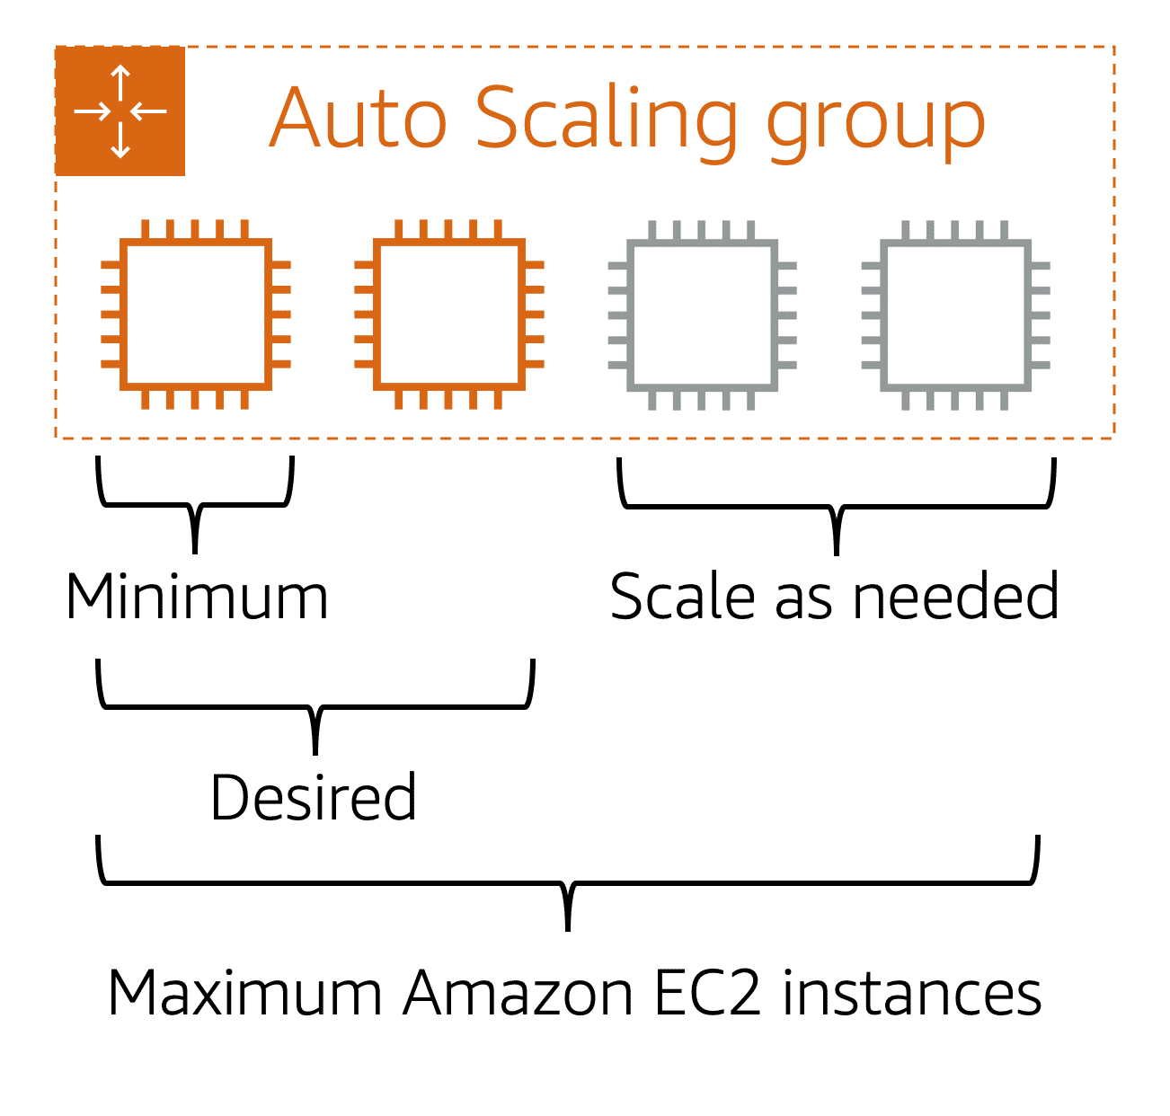

To scale faster, you can use dynamic scaling and predictive scaling together.

Amazon EC2 Auto Scaling. Adds instances based on demand and then decommissions instances when they are no longer needed. This means that every minute of the day, you always have the correct number of instances. Happy customers. Happy CFO. Happy architecture.

When you create an Auto Scaling group, you can set the minimum number of Amazon EC2 instances. Next, you can set the **desired capacity** at two Amazon EC2 instances even though your application needs a minimum of a single Amazon EC2 instance to run.

# 2-4. Directing Traffic with Elastic Load Balancing

A host stands at the door and when customers come into the coffee shop, they tell them which line to proceed to for placing their order. The host keeps an eye on the cashier's taking orders, and counts the number of people in line each cashier is serving. Then it will direct new customers to the cashier that has the shortest line, that's the least bogged down, thus allowing the lines to be even across cashiers and helping customers be served in the most efficient manner possible.

The same idea applies to your AWS environment. When you have multiple EC2 instances all running the same program, to serve the same purpose, and a request comes in, how does that request know which EC2 instance to go to? How can you ensure there's an even distribution of workload across EC2 instances? So not just one is backed up while the others are idle sitting by. You need a way to route requests to instances to process that request. What you need to solve this is called load balancing.

Introducing Elastic Load Balancing. Elastic Load Balancing, or ELB, is one of the first major managed services we're going to talk about in this course. And it's engineered to address the undifferentiated heavy lifting of load balancing. To illustrate this point, I need to zoom out a bit here. To begin with, Elastic Load Balancing is a regional construct, and we'll explain more of what that means in later videos. But the key value for you is that because it runs at the Region level rather than on individual EC2 instances, the service is automatically highly available with no additional effort on your part.

Well, we solve the back end traffic chaos with an ELB as well. Because ELB is regional, it's a single URL that each front end instance uses. Then the ELB directs traffic to the back end that has the least outstanding requests. Now, if the back end scales, once the new instance is ready, it just tells the ELB that it can take traffic, and it gets to work. The front end doesn't know and doesn't care how many back end instances are running. This is true decoupled architecture.

**Elastic Load Balancing**

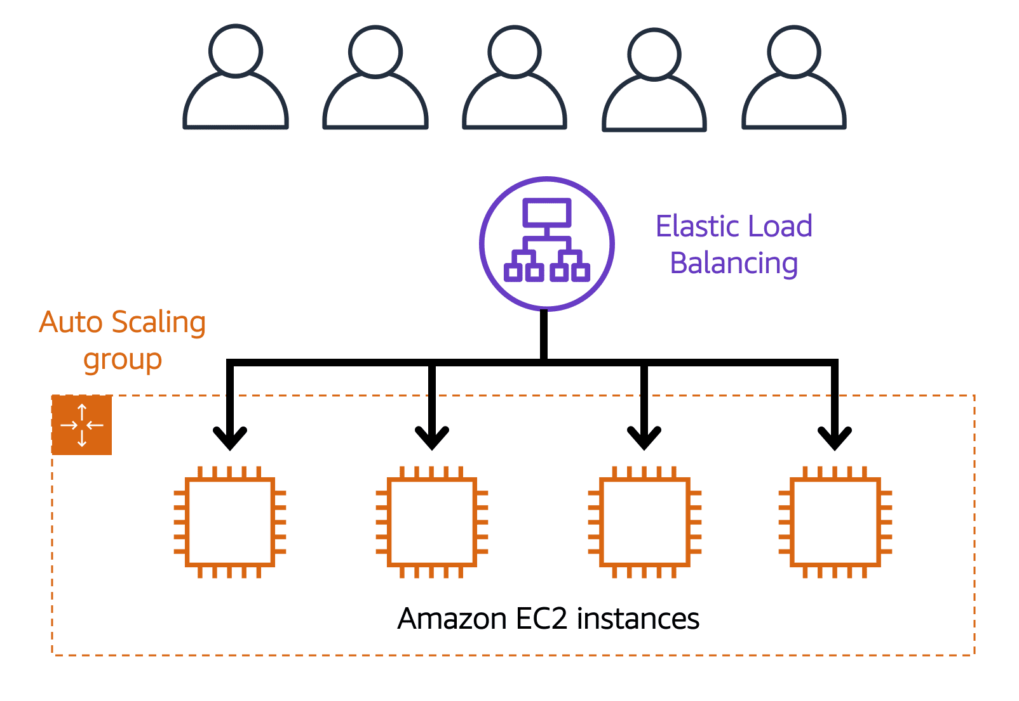**Elastic Load Balancing** is the AWS service that automatically distributes incoming application traffic across multiple resources, such as Amazon EC2 instances.

A load balancer acts as a single point of contact for all incoming web traffic to your Auto Scaling group. This means that as you add or remove Amazon EC2 instances in response to the amount of incoming traffic, these requests route to the load balancer first. Then, the requests spread across multiple resources that will handle them.

Although Elastic Load Balancing and Amazon EC2 Auto Scaling are separate services, they work together to help ensure that applications running in Amazon EC2 can provide high performance and availability.

Ensuring that no single Amazon EC2 instance has to carry the full workload on its own. This helps to ensure that no single resource becomes overutilized.

# 2-5. Messaging and Queuing

A hallmark trait of a tightly coupled architecture is where if a single component fails or changes, it causes issues for other components or even the whole system. For example, if we have Application A and it is sending messages directly to Application B, if Application B has a failure and cannot accept those messages, Application A will begin to see errors as well. This is a tightly coupled architecture.

A more reliable architecture is loosely coupled. This is an architecture where if one component fails, it is isolated and therefore won't cause cascading failures throughout the whole system. If we coded the application to use a more loosely coupled architecture, it could look as follows.

First up, let's discuss Amazon SQS. SQS allows you to send, store, and receive messages between software components at any volume. This is without losing messages or requiring other services to be available. Think of messages as our coffee orders and the order board as an SQS queue. Messages have the person's name, coffee order, and time they ordered. The data contained within a message is called a payload, and it's protected until delivery. SQS queues are where messages are placed until they are processed. And AWS manages the underlying infrastructure for you to host those queues. These scale automatically, are reliable, and are easy to configure and use.

Now, Amazon SNS is similar in that it is used to send out messages to services, but it can also send out notifications to end users. It does this in a different way called a publish/subscribe or pub/sub model. This means that you can create something called an SNS topic which is just a channel for messages to be delivered. You then configure subscribers to that topic and finally publish messages for those subscribers. In practice, that means you can send one message to a topic which will then fan out to all the subscribers in a single go. These subscribers can also be endpoints such as SQS queues, AWS Lambda functions, and HTTPS or HTTP web hooks.

Additionally, SNS can be used to fan out notifications to end users using mobile push, SMS, and email. Taking this back to our coffee shop, we could send out a notification when a customer's order is ready. This could be a simple SMS to let them know to pick it up or even a mobile push.

**1) Monolithic applications and microservices**

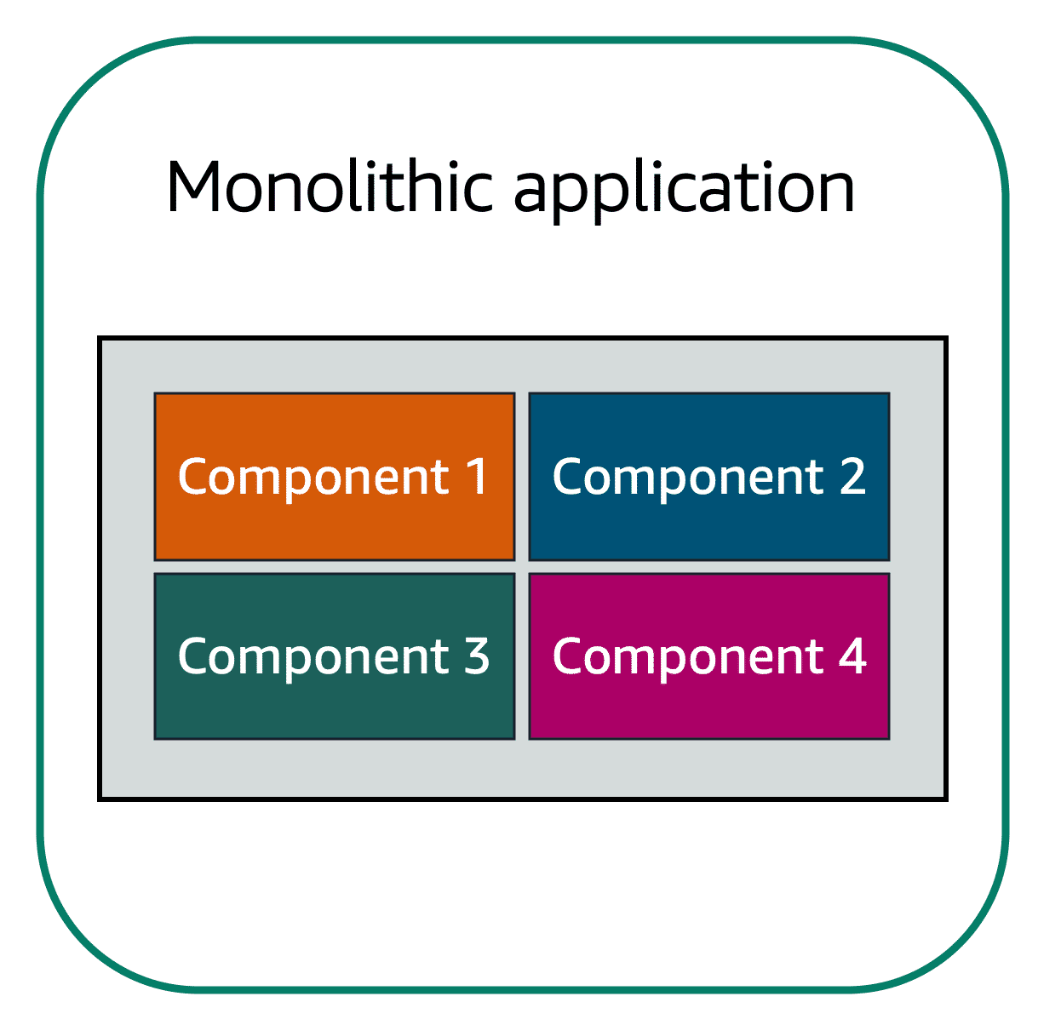Suppose that you have an application with tightly coupled components. These components might include databases, servers, the user interface, business logic, and so on. This type of architecture can be considered a **monolithic application**.

In this approach to application architecture, if a single component fails, other components fail, and possibly the entire application fails.

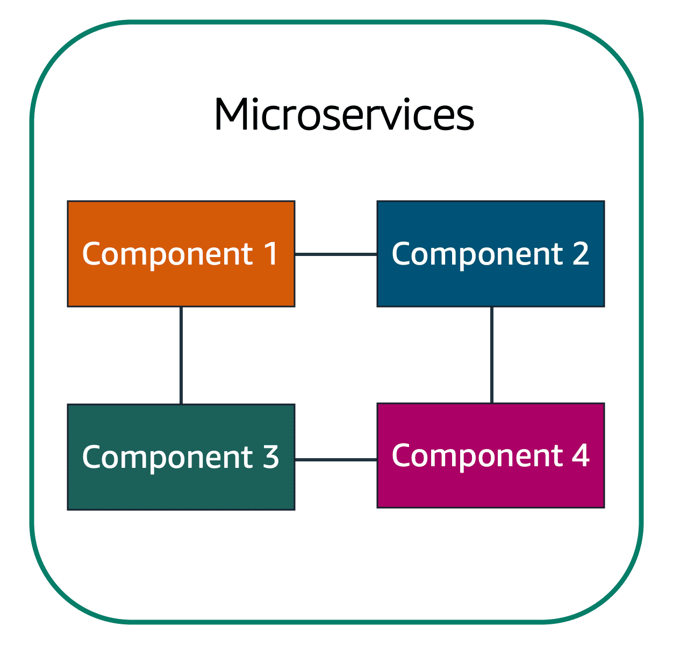In a microservices approach, application components are loosely coupled. In this case, if a single component fails, the other components continue to work because they are communicating with each other. The loose coupling prevents the entire application from failing.

When designing applications on AWS, you can take a microservices approach with services and components that fulfill different functions. Two services facilitate application integration: Amazon Simple Notification Service (Amazon SNS) and Amazon Simple Queue Service (Amazon SQS).

**2) Amazon Simple Notification Service (Amazon SNS)**

**Amazon Simple Notification Service (Amazon SNS)**is a publish/subscribe service. Using Amazon SNS topics, a publisher publishes messages to subscribers. This is similar to the coffee shop; the cashier provides coffee orders to the barista who makes the drinks.

In Amazon SNS, subscribers can be web servers, email addresses, AWS Lambda functions, or several other options.

*Which AWS service is the best choice for publishing messages to subscribers?*

**3) Amazon Simple Queue Service (Amazon SQS)**

**Amazon Simple Queue Service (Amazon SQS)** is a message queuing service.

Using Amazon SQS, you can send, store, and receive messages between software components, without losing messages or requiring other services to be available. In Amazon SQS, an application sends messages into a queue. A user or service retrieves a message from the queue, processes it, and then deletes it from the queue.

# 2-6. Additional Compute Services

AWS offers multiple serverless compute options. Serverless means that you cannot actually see or access the underlying infrastructure or instances that are hosting your application. Instead, all the management of the underlying environment from a provisioning, scaling, high availability, and maintenance perspective are taken care of for you. All you need to do is focus on your application and the rest is taken care of.

**Serverless computing**

Earlier in this module, you learned about Amazon EC2, a service that lets you run virtual servers in the cloud. If you have applications that you want to run in Amazon EC2, you must do the following:

1 Provision instances (virtual servers)

2 Upload your code.

3 Continue to manage the instances while your application is running.

The term “serverless” means that your code runs on servers, but you do not need to provision or manage these servers. With serverless computing, you can focus more on innovating new products and features instead of maintaining servers.

**1) AWS Lambda**

[**AWS Lambda**](https://aws.amazon.com/lambda) is a service that lets you run code without needing to provision or manage servers.

While using AWS Lambda, you pay only for the compute time that you consume. Charges apply only when your code is running. You can also run code for virtually any type of application or backend service, all with zero administration.

For example, a simple Lambda function might involve automatically resizing uploaded images to the AWS Cloud. In this case, the function triggers when uploading a new image.

**2) Containers**

**Containers** provide you with a standard way to package your application's code and dependencies into a single object. You can also use containers for processes and workflows in which there are essential requirements for security, reliability, and scalability.

**2-1) Amazon Elastic Container Service (Amazon ECS)**

[**Amazon Elastic Container Service (Amazon ECS)**](https://aws.amazon.com/ecs/) is a highly scalable, high-performance container management system that enables you to run and scale containerized applications on AWS.

Amazon ECS supports Docker containers. [Docker](https://www.docker.com/) is a software platform that enables you to build, test, and deploy applications quickly. AWS supports the use of open-source Docker Community Edition and subscription-based Docker Enterprise Edition. With Amazon ECS, you can use API calls to launch and stop Docker-enabled applications.

**2-2) Amazon Elastic Kubernetes Service (Amazon EKS)**

[**Amazon Elastic Kubernetes Service (Amazon EKS)**](https://aws.amazon.com/eks/)is a fully managed service that you can use to run Kubernetes on AWS.

[Kubernetes](https://kubernetes.io/) is open-source software that enables you to deploy and manage containerized applications at scale. A large community of volunteers maintains Kubernetes, and AWS actively works together with the Kubernetes community. As new features and functionalities release for Kubernetes applications, you can easily apply these updates to your applications managed by Amazon EKS.

**2-3) AWS Fargate**

[**AWS Fargate**](https://aws.amazon.com/fargate/) is a **serverless compute engine** for containers. It works with both Amazon ECS and Amazon EKS.

When using AWS Fargate, you do not need to provision or manage servers. AWS Fargate manages your server infrastructure for you. You can focus more on innovating and developing your applications, and you pay only for the resources that are required to run your containers.

# Module 3 Global Infrastructure and Reliability

**3-1. Selecting a Region**

When determining the right Region for your services, data, and applications, consider the following four business factors.

A Region consists of three or more Availability Zones.

**1) Compliance with data governance and legal requirements**

Depending on your company and location, you might need to run your data out of specific areas. For example, if your company requires all of its data to reside within the boundaries of the UK, you would choose the London Region. Not all companies have location-specific data regulations, so you might need to focus more on the other three factors.

**2) Proximity to your customers**

Selecting a Region that is close to your customers will help you to get content to them faster. For example, your company is based in Washington, DC, and many of your customers live in Singapore. You might consider running your infrastructure in the Northern Virginia Region to be close to company headquarters, and run your applications from the Singapore Region.

**3)Available services within a Region**

Sometimes, the closest Region might not have all the features that you want to offer to customers. AWS is frequently innovating by creating new services and expanding on features within existing services. However, making new services available around the world sometimes requires AWS to build out physical hardware one Region at a time.

Suppose that your developers want to build an application that uses Amazon Braket (AWS quantum computing platform). As of this course, Amazon Braket is not yet available in every AWS Region around the world, so your developers would have to run it in one of the Regions that already offers it.

**4) Pricing**

Suppose that you are considering running applications in both the United States and Brazil. The way Brazil’s tax structure is set up, it might cost 50% more to run the same workload out of the São Paulo Region compared to the Oregon Region. You will learn in more detail that several factors determine pricing, but for now know that the cost of services can vary from Region to Region.

**3-2. Availability Zones (zone은 data center 단위, zone이 모이면 region)**

An **Availability Zone** is **a single data center or a group of data centers within a Region**. Availability Zones are located tens of miles apart from each other. This is close enough to have low latency (the time between when content requested and received) between Availability Zones. However, if a disaster occurs in one part of the Region, they are distant enough to reduce the chance that multiple Availability Zones are affected.

# 3-3. Edge Locations

An **edge location** is a site that Amazon CloudFront uses to store cached copies of your content closer to your customers for faster delivery.

Amazon CloudFront is a content delivery service. It uses a network of edge locations to cache content and deliver content to customers all over the world. When content is cached, it is stored locally as a copy. This content might be video files, photos, webpages, and so on.

To learn more, choose each of the numbered markers.

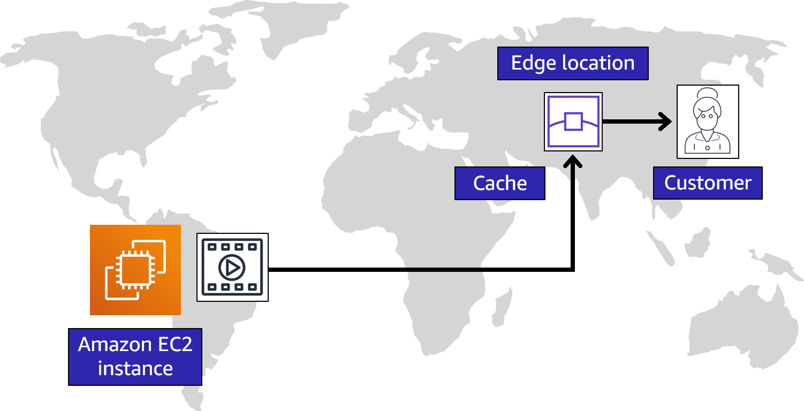

# 3-4. How to Provision AWS Resources

# **1) Ways to interact with AWS services**

# 1-1) The AWS Management Console is a web-based interface for accessing and managing AWS services. You can quickly access recently used services and search for other services by name, keyword, or acronym. The console includes wizards and automated workflows that can simplify the process of completing tasks.

# You can also use the AWS Console mobile application to perform tasks such as monitoring resources, viewing alarms, and accessing billing information. Multiple identities can stay logged into the AWS Console mobile app at the same time.

**1-2)** To save time when making API requests, you can use the **AWS Command Line Interface (AWS CLI)**. AWS CLI enables you to control multiple AWS services directly from the command line within one tool. AWS CLI is available for users on Windows, macOS, and Linux.

By using AWS CLI, you can automate the actions that your services and applications perform through scripts. For example, you can use commands to launch an Amazon EC2 instance, connect an Amazon EC2 instance to a specific Auto Scaling group, and more.

**1-3)** Another option for accessing and managing AWS services is the **software development kits (SDKs)**. SDKs make it easier for you to use AWS services through an API designed for your programming language or platform. SDKs enable you to use AWS services with your existing applications or create entirely new applications that will run on AWS.

To help you get started with using SDKs, AWS provides documentation and sample code for each supported programming language. Supported programming languages include C++, Java, .NET, and more.

**2) AWS Elastic Beanstalk**

With **AWS Elastic Beanstalk**, you provide **code and configuration settings**, and Elastic Beanstalk **deploys the resources necessary** to perform the following tasks:

* Adjust capacity
* Load balancing
* Automatic scaling
* Application health monitoring

**3) AWS CloudFormation**

With **AWS CloudFormation**, you can treat your **infrastructure as code**. This means that you can build an environment by writing lines of code instead of using the AWS Management Console to individually provision resources.

AWS CloudFormation provisions your resources in a safe, repeatable manner, enabling you to frequently build your infrastructure and applications without having to perform manual actions. It determines the right operations to perform when managing your stack and rolls back changes automatically if it detects errors.

# 4) AWS Outposts Family overview

AWS Outposts is a family of fully managed solutions delivering AWS infrastructure and services to virtually any on-premises or edge location for a truly consistent hybrid experience. Outposts solutions allow you to extend and run native AWS services on premises, and is available in a variety of form factors, from 1U and 2U Outposts servers to 42U Outposts racks, and multiple rack deployments.

With AWS Outposts, you can run some AWS services locally and connect to a broad range of services available in the local AWS Region. Run applications and workloads on premises using familiar AWS services, tools, and APIs. Outposts supports workloads and devices requiring low latency access to on-premises systems, local data processing, data residency, and application migration with local system interdependencies.

# Module 4 Networking

# 4-1. Connectivity to AWS

**1) Amazon Virtual Private Cloud (Amazon VPC)**

Imagine the millions of customers who use AWS services. Also, imagine the millions of resources that these customers have created, such as Amazon EC2 instances. Without boundaries around all of these resources, network traffic would be able to flow between them unrestricted.

A **networking service** that you can use to establish **boundaries around your AWS resources** is [**Amazon Virtual Private Cloud (Amazon VPC)**](https://aws.amazon.com/vpc/) .

Amazon VPC enables you to provision an isolated section of the AWS Cloud. In this isolated section, you can launch resources in a virtual network that you define. Within a virtual private cloud (VPC), you can organize your resources into subnets. A **subnet** is a section of a VPC that can contain resources such as Amazon EC2 instances.

**2) Internet gateway**

To allow public traffic from the internet to access your VPC, you attach an **internet gateway** to the VPC.

Internet gateway icon attached to a VPC that holds three EC2 instances. An arrow connects the client to the gateway over the internet indicating that the client's request has gained access to the VPC.

An internet gateway is a connection between a VPC and the internet. You can think of an internet gateway as being similar to a doorway that customers use to enter the coffee shop. Without an internet gateway, no one can access the resources within your VPC.

**3) Virtual private gateway**

To access private resources in a VPC, you can use a **virtual private gateway**.

Here’s an example of how a virtual private gateway works. You can think of the internet as the road between your home and the coffee shop. Suppose that you are traveling on this road with a bodyguard to protect you. You are still using the same road as other customers, but with an extra layer of protection.

The bodyguard is like a virtual private network (VPN) connection that encrypts (or protects) your internet traffic from all the other requests around it.

The virtual private gateway is the component that allows protected internet traffic to enter into the VPC. Even though your connection to the coffee shop has extra protection, traffic jams are possible because you’re using the same road as other customers.

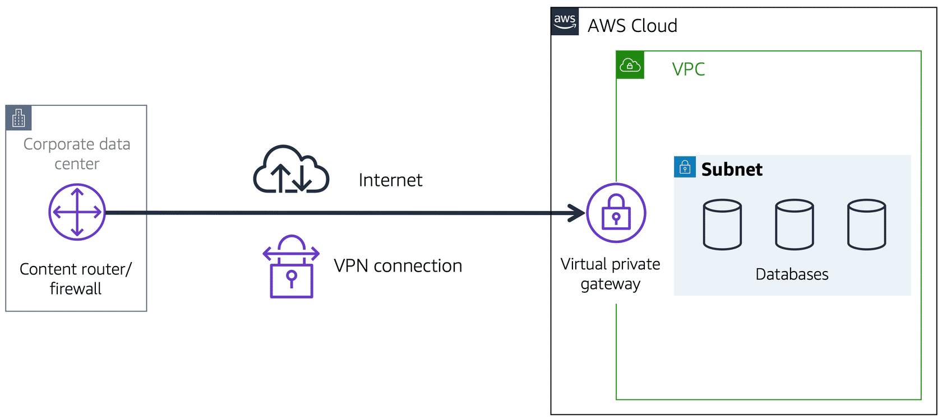

A virtual private gateway enables you to establish a virtual private network (VPN) connection between your VPC and a private network, such as an on-premises data center or internal corporate network. A virtual private gateway allows traffic into the VPC only if it is coming from an approved network.

**4) AWS Direct Connect**

[**AWS Direct Connect**](https://aws.amazon.com/directconnect/) is a service that lets you to establish a dedicated private connection between your **data center and a VPC**.

Suppose that there is an apartment building with a hallway directly linking the building to the coffee shop. Only the residents of the apartment building can travel through this hallway.

This private hallway provides the same type of dedicated connection as AWS Direct Connect. Residents are able to get into the coffee shop without needing to use the public road shared with other customers.

The private connection that AWS Direct Connect provides helps you to **reduce network costs** and **increase the amount of bandwidth** that can travel through your network.

A corporate data center routes network traffic to an AWS Direct Connect location. That traffic is then routed to a VPC through a virtual private gateway. All network traffic between the corporate data center and VPC flows through this dedicated private connection.

# 4-2. Subnets and Network Access Control Lists

**1) Subnets**

A subnet is a **section of a VPC** in which you can group resources based on **security or operational needs**. Subnets can be public or private.

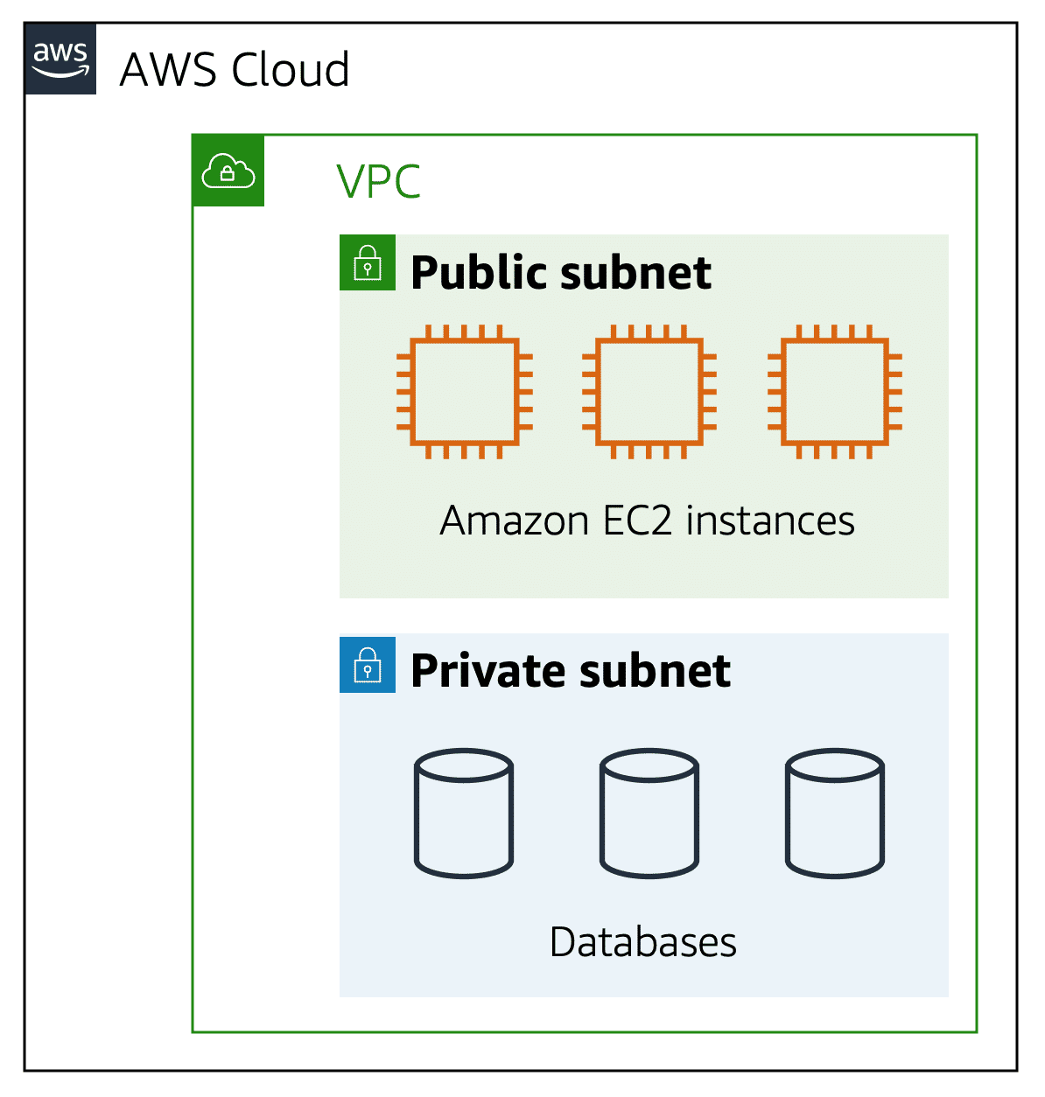

**Public subnets** contain resources that need to be accessible by the public, such as an online store’s website.

**Private subnets** contain resources that should be accessible only through your private network, such as a database that contains customers’ personal information and order histories.

In a VPC, subnets can communicate with each other. For example, you might have an application that involves Amazon EC2 instances in a public subnet communicating with databases that are located in a private subnet.

**2) Network traffic in a VPC**

When a customer requests data from an application hosted in the AWS Cloud, this request is sent as a packet. A **packet** is a unit of data sent over the internet or a network.

It enters into a VPC through an internet gateway. Before a packet can enter into a subnet or exit from a subnet, it checks for permissions. These permissions indicate who sent the packet and how the packet is trying to communicate with the resources in a subnet. The VPC component that checks packet permissions for subnets is a [**network access control list (ACL)**](https://docs.aws.amazon.com/vpc/latest/userguide/vpc-network-acls.html) .

**3) Network ACLs**

A network ACL is a **virtual firewall that controls inbound and outbound traffic at the subnet level**.

For example, step outside of the coffee shop and imagine that you are in an airport. In the airport, travelers are trying to enter into a different country. You can think of the travelers as packets and **the passport control officer as a network ACL**. The passport control officer checks travelers’ credentials when they are both entering and exiting out of the country. If a traveler is on an approved list, they are able to get through. However, if they are not on the approved list or are explicitly on a list of banned travelers, they cannot come in.

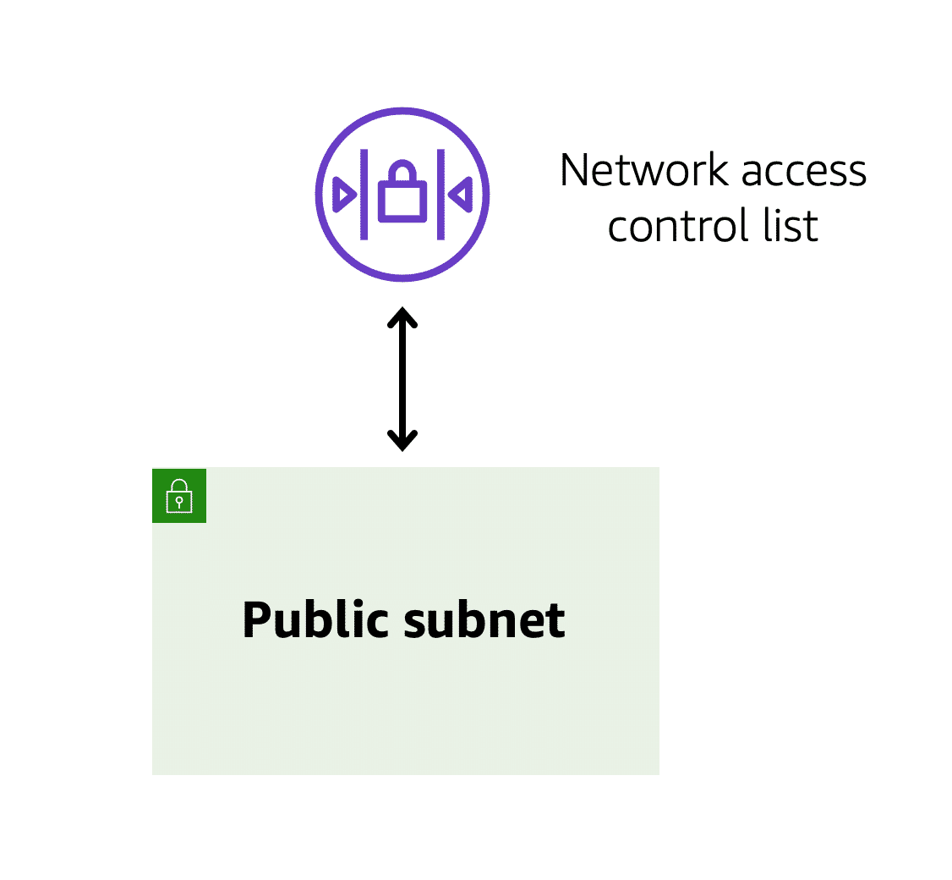Each AWS account includes a default network ACL. When configuring your VPC, you can use your account’s default network ACL or create custom network ACLs.

By default, your account’s default network ACL **allows** all inbound and outbound traffic, but you can modify it by adding your own rules. For custom network ACLs, all inbound and outbound traffic is denied until you add rules to specify which traffic to allow. Additionally, **all network ACLs have an explicit deny rule**. This rule ensures that if a packet doesn’t match any of the other rules on the list, the packet is denied.

**4) Stateless packet filtering**

**Network ACLs perform stateless packet filtering**. **They remember nothing** and check packets that cross the subnet border each way: inbound and outbound.

Recall the previous example of a traveler who wants to enter into a different country. This is similar to sending a request out from an Amazon EC2 instance and to the internet.

When a packet response for that request comes back to the subnet, the network ACL does not remember your previous request. The network ACL checks the packet response against its list of rules to determine whether to allow or deny.

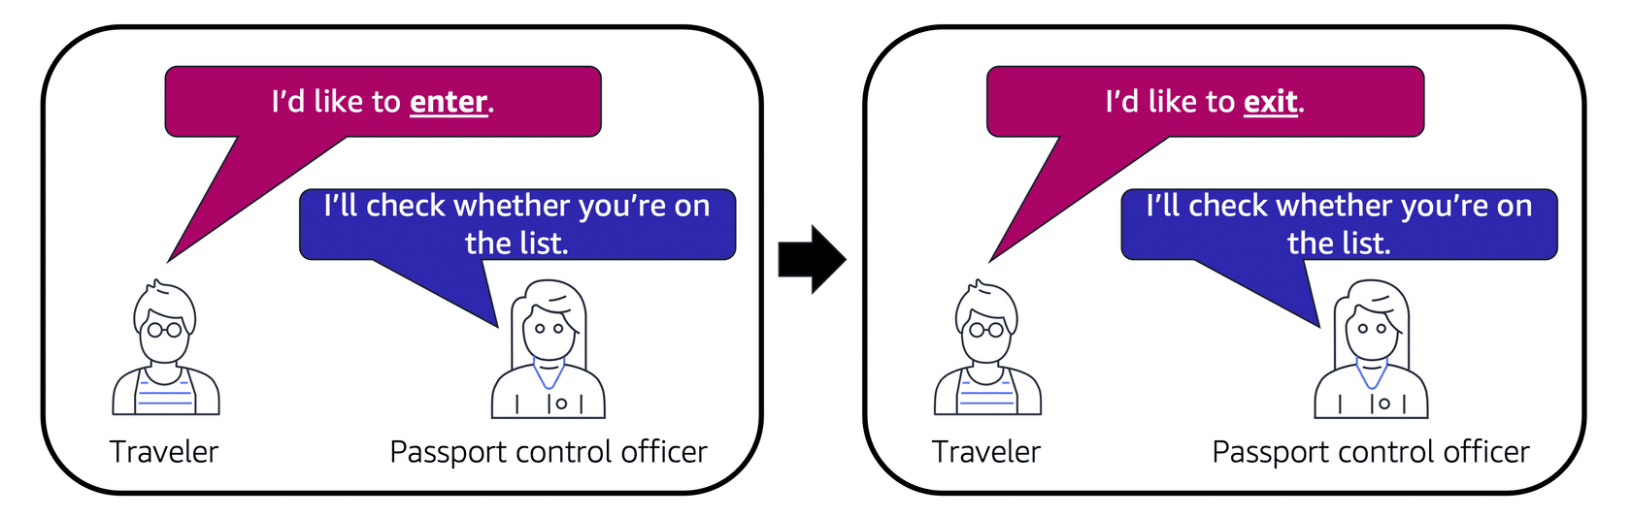After a packet has entered a subnet, it must have its permissions evaluated for resources within the subnet, such as Amazon EC2 instances.

The VPC component that checks packet permissions for an Amazon EC2 instance is a [**security group**](https://docs.aws.amazon.com/vpc/latest/userguide/VPC_SecurityGroups.html).

**5) Security groups**

**A security group is a virtual firewall** that **controls inbound and outbound traffic for an Amazon EC2 instance**.

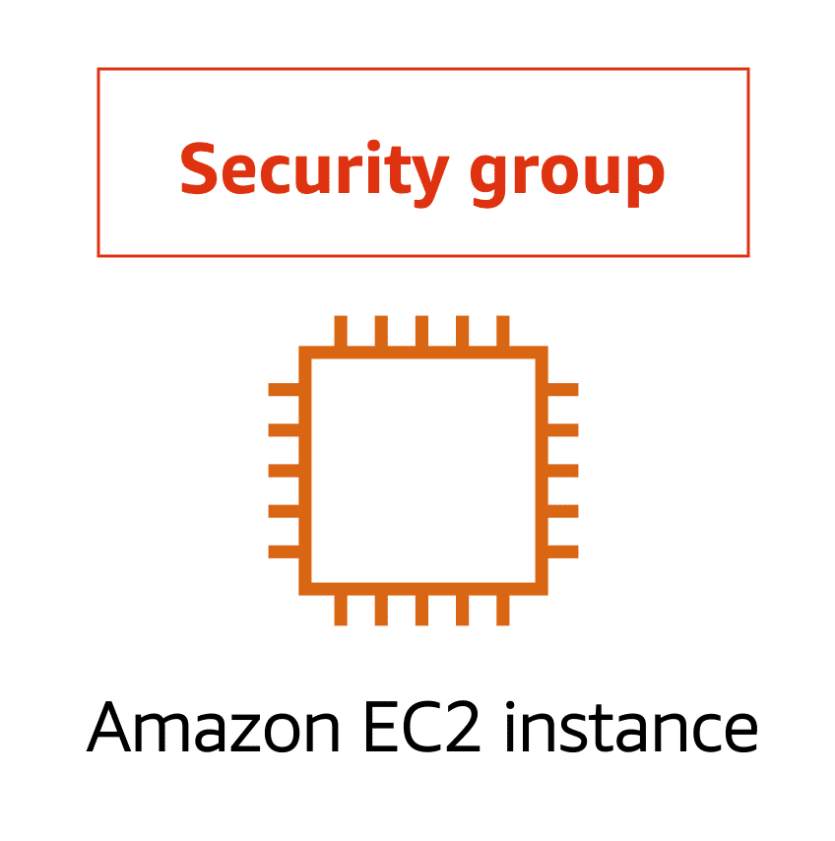By default, a security group **denies** all inbound traffic and allows all outbound traffic. You can add custom rules to configure which traffic should be allowed; any other traffic would then be denied.

For this example, suppose that you are in an apartment building with a door attendant who greets guests in the lobby. You can think of the guests as packets and the door attendant as a security group. As guests arrive, the door attendant checks a list to ensure they can enter the building. However, the door attendant does not check the list again when guests are exiting the building.

If you have multiple Amazon EC2 instances within the same VPC, you can associate them with the same security group or use different security groups for each instance.

**6) Stateful packet filtering**

Security groups perform **stateful** packet filtering. **They remember previous decisions made for incoming packets.**

Consider the same example of sending a request out from an Amazon EC2 instance to the internet.

When a packet response for that request returns to the instance, the security group remembers your previous request. The security group allows the response to proceed, regardless of inbound security group rules.

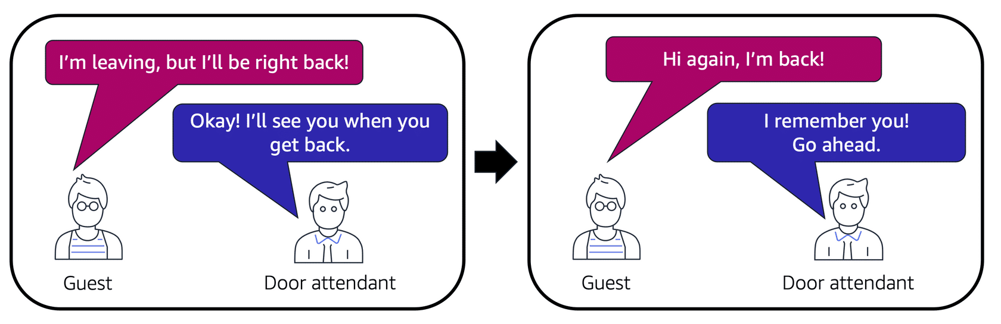

With both network ACLs and security groups, you can configure custom rules for the traffic in your VPC. As you continue to learn more about AWS security and networking, make sure to understand the differences between network ACLs and security groups.

A packet travels over the internet from a client to the internet gateway and into the VPC. Then the pack goes through the network access control list and accesses the public subnet, where two EC2 instances are located.

**7) VPC component recall**

Recall the purpose of the following four VPC components. Compare your response by choosing each VPC component flashcard.

To practice recalling VPC components, select each of the following flashcards by choosing them.

# 4-3. Global Networking

**1) Amazon Route 53**

[**Amazon Route 53**(opens in a new tab)](https://aws.amazon.com/route53) is a DNS web service. It gives developers and businesses a **reliable way to route end users to internet applications hosted in AWS**.

Amazon Route 53 connects user requests to infrastructure running in AWS (such as Amazon EC2 instances and load balancers). It can route users to infrastructure outside of AWS.

Another feature of Route 53 is the ability to manage the DNS records for domain names. You can register new domain names directly in Route 53. You can also transfer DNS records for existing domain names managed by other domain registrars. This enables you to manage all of your domain names within a single location.

In the previous module, you learned about Amazon CloudFront, a content delivery service. The following example describes how Route 53 and Amazon CloudFront work together to deliver content to customers.

# Module 5 Storage and Databases

# 5-1. Instance Stores and Amazon Elastic Block Store (Amazon EBS)

**Instance stores**

Block-level storage volumes behave like physical hard drives.

An [**instance store**](https://docs.aws.amazon.com/AWSEC2/latest/UserGuide/InstanceStorage.html) provides temporary block-level storage for an Amazon EC2 instance. An instance store is disk storage that is physically attached to the host computer for an EC2 instance, and therefore has the same lifespan as the instance. When the instance is terminated, you lose any data in the instance store.

2) [**Amazon Elastic Block Store (Amazon EBS)**](https://aws.amazon.com/ebs) is a service that provides block-level storage volumes that you can use with Amazon EC2 instances. If you stop or terminate an Amazon EC2 instance, all the data on the attached EBS volume remains available.

To create an EBS volume, you define the configuration (such as volume size and type) and provision it. After you create an EBS volume, it can attach to an Amazon EC2 instance.

Because EBS volumes are for data that needs to persist, it’s important to back up the data. You can take incremental backups of EBS volumes by creating Amazon EBS snapshots.

Incremental backups of EBS volumes with Amazon EBS snapshots. On Day 1, two volumes are backed up. Day 2 adds one new volume, and the new volume is backed up. Day 3 adds two more volumes for a total of five volumes. Only the two new volumes are backed up.

# 5-2. Amazon Simple Storage Service (Amazon S3)

[**Amazon Simple Storage Service (Amazon S3)**(opens in a new tab)](https://aws.amazon.com/s3/) is a service that provides object-level storage. Amazon S3 stores data as objects in buckets.

You can upload any type of file to Amazon S3, such as images, videos, text files, and so on. For example, you might use Amazon S3 to store backup files, media files for a website, or archived documents. Amazon S3 offers unlimited storage space. The maximum file size for an object in Amazon S3 is 5 TB.

When you upload a file to Amazon S3, you can set permissions to control visibility and access to it. You can also use the Amazon S3 versioning feature to track changes to your objects over time.

**1) Amazon S3 storage classes**

When selecting an Amazon S3 storage class, consider these two factors:

* How often you plan to retrieve your data
* How available you need your data to be

**1-1) S3 Standard**

* Designed for frequently accessed data
* Stores data in a minimum of three Availability Zones

Amazon S3 Standard provides high availability for objects. This makes it a good choice for a wide range of use cases, such as websites, content distribution, and data analytics. **Amazon S3 Standard has a higher cost** than other storage classes intended for infrequently accessed data and archival storage.

**1-2) S3 Standard-Infrequent Access (S3 Standard-IA)**

* Ideal for infrequently accessed data
* Similar to Amazon S3 Standard but has a lower storage price and higher retrieval price

Amazon S3 Standard-IA is ideal for data infrequently accessed but requires **high availability when needed**. Both Amazon S3 Standard and Amazon S3 Standard-IA store data in a **minimum of three Availability Zones**. Amazon S3 Standard-IA provides the same level of availability as Amazon S3 Standard but with a **lower storage price** and a **higher retrieval price**.

*You want to store data that is infrequently accessed but must be immediately available when needed.*

**1-3) S3 One Zone-Infrequent Access (S3 One Zone-IA)**

* Stores data in a single Availability Zone
* Has a lower storage price than Amazon S3 Standard-IA

Compared to S3 Standard and S3 Standard-IA, which store data in a minimum of three Availability Zones, S3 One Zone-IA stores data **in a single Availability Zone**. This makes it a good storage class to consider if the following conditions apply:

* You want to save costs on storage.
* **You can easily reproduce your data in the event of an Availability Zone failure**.

**1-4) S3 Intelligent-Tiering (접근 많이 안 하면 자동으로 tier를 바꿔서 돈을 세이브함)**

* Ideal for data with unknown or changing access patterns
* Requires a small monthly monitoring and automation fee per object

In the S3 Intelligent-Tiering storage class, Amazon S3 monitors objects’ access patterns. If you haven’t accessed an object for 30 consecutive days, Amazon S3 automatically moves it to the infrequent access tier, S3 Standard-IA. If you access an object in the infrequent access tier, Amazon S3 automatically moves it to the frequent access tier, S3 Standard.

**1-5) S3 Glacier Instant Retrieval**

* Works well for archived data that requires immediate access
* Can retrieve objects within a few milliseconds

When you decide between the options for archival storage, consider how quickly you must retrieve the archived objects. You can retrieve objects stored in the S3 Glacier Instant Retrieval storage class within milliseconds, with the same performance as S3 Standard.

**1-6) S3 Glacier Flexible Retrieval**

* Low-cost storage designed for **data archiving.**
* Able to retrieve objects within a few minutes to hours.

S3 Glacier Flexible Retrieval is a low-cost storage class that is ideal for data archiving. For example, you might use this storage class to store archived customer records or older photos and video files. You can retrieve your data from S3 Glacier Flexible Retrieval from 1 minute to 12 hours.

**1-7) S3 Glacier Deep Archive**

* **Lowest-cost object storage** class ideal for archiving
* Able to retrieve objects within 12 hours

S3 Deep Archive supports long-term retention and digital preservation for data that might be **accessed once or twice in a year**. This storage class is the lowest-cost storage in the AWS Cloud, with data retrieval from 12 to 48 hours. All objects from this storage class are replicated and stored across at least three geographically dispersed Availability Zones.

**1-8) S3 Outposts**

* Creates S3 buckets on Amazon S3 Outposts
* Makes it easier to retrieve, store, and access data on AWS Outposts

**Amazon S3** Outposts **delivers object storage to your on-premises AWS Outposts environment**. Amazon S3 Outposts is designed to store data durably and redundantly across multiple devices and servers on your Outposts. It works well for workloads with local data residency requirements that must satisfy demanding performance needs by keeping data close to on-premises applications.

# **2) Comparing Amazon EBS and Amazon S3**

# In the block storage corner, weighing in at sizes up to 16 tebibytes each, with a unique ability to survive the termination of their Amazon EC2 instances, they are solid state, they are spinning platters, they are Amazon Elastic Block Storage!

# In the regional object storage corner, weighing in at unlimited storage, with individual objects at 5,000 gigabytes in size, they specialize in write once/read many, they are 99 .999 999 999% durable, they are Amazon Simple Storage Service!

# Round one. Let's say you're running a photo analysis website where users upload a photo of themselves, and your application finds the animals that look just like them. You have potentially millions of animal pictures that all need to be indexed and possibly viewed by thousands of people at once. This is the perfect use case for S3. S3 is already web enabled. Every object already has a URL that you can control access rights to who can see or manage the image. It's regionally distributed, which means that it has 11 nines of durability, so no need to worry about backup strategies. S3 is your backup strategy. Plus the cost savings is substantial overrunning the same storage load on EBS. With the additional advantage of being serverless, no Amazon EC2 instances are needed. Sounds like S3 is the judge's winner here for this round.

# But wait, round two, you have an 80-gigabyte video file that you're making edit corrections on. To know the best storage class here, we need to understand the difference between object storage and block storage. Object storage treats any file as a complete, discreet object. Now this is great for documents, and images, and video files that get uploaded and consumed as entire objects, but every time there's a change to the object, you must re-upload the entire file. There are no delta updates. Block storage breaks those files down to small component parts or blocks. This means, for that 80-gigabyte file, when you make an edit to one scene in the film and save that change, the engine only updates the blocks where those bits live. If you're making a bunch of micro edits, using EBS, elastic block storage, is the perfect use case. If you were using S3, every time you saved the changes, the system would have to upload all 80 gigabytes, the whole thing, every time. EBS clearly wins round two.

# This means, if you are using complete objects or only occasional changes, S3 is victorious. If you are doing complex read, write, change functions, then, absolutely, EBS is your knockout winner. Your winner depends on your individual workload. Each service is the right service for specific needs. Once you understand what you need, you will know which service is your champion!

# 5-3. Amazon Elastic File System (Amazon EFS)

**1) File storage**

In **file storage**, multiple clients (such as users, applications, servers, and so on) can access data that is stored in shared file folders. In this approach, a storage server uses **block storage** with a local file system to organize files. Clients access data through file paths.

Compared to block storage and object storage, **file storage is ideal for use cases in which a large number of services and resources** need to access the same data at the same time.

[**Amazon Elastic File System (Amazon EFS)**](https://aws.amazon.com/efs/) is a scalable file system used with AWS Cloud services and on-premises resources. As you add and remove files, Amazon EFS grows and shrinks automatically. It can scale on demand to petabytes without disrupting applications.

**2) Comparing Amazon EBS and Amazon EFS**

**5-4. Amazon Relational database Service**

**1) Relational databases**

In a **relational database**, data is stored in a way that relates it to other pieces of data.

Relational databases use **structured query language (SQL)** to store and query data. This approach allows data to be stored in an easily understandable, consistent, and scalable way. For example, the coffee shop owners can write a SQL query to identify all the customers whose most frequently purchased drink is a medium latte.

**2)Amazon Relational Database Service**

[**Amazon Relational Database Service (Amazon RDS)**](https://aws.amazon.com/rds/) is a service that enables you to run relational databases in the AWS Cloud.

Amazon RDS is a managed service that automates tasks such as **hardware provisioning, database setup, patching, and backups**. With these capabilities, you can spend less time completing administrative tasks and more time using data to innovate your applications. You can integrate Amazon RDS with other services to fulfill your business and operational needs, such as using AWS Lambda to query your database from a serverless application.

Amazon RDS provides a number of different security options. Many Amazon RDS database engines offer encryption **at rest (protecting data while it is stored)** and **encryption in transit** (protecting data while it is being sent and received).

**3) Amazon RDS database engines**

Amazon RDS is available on six database engines, which optimize for memory, performance, or input/output (I/O). Supported database engines include:

* Amazon Aurora
* PostgreSQL
* MySQL
* MariaDB
* Oracle Database
* Microsoft SQL Server

**4) Amazon Aurora**

[**Amazon Aurora**](https://aws.amazon.com/rds/aurora/) is an **enterprise-class relational database**. It is compatible with MySQL and PostgreSQL relational databases. It is up to five times faster than standard MySQL databases and up to three times faster than standard PostgreSQL databases.

Amazon Aurora helps to reduce your database costs by reducing unnecessary input/output (I/O) operations, while ensuring that your database resources remain reliable and available.

Consider Amazon Aurora if your workloads require high availability. **It replicates six copies of your data across three Availability Zones and continuously backs up your data to Amazon S3**.

# 5-5. Amazon DynamoDB

**1) Nonrelational databases**

In a **nonrelational database**, you create tables. A table is a place where you can store and query data.

Nonrelational databases are sometimes referred to as **“NoSQL databases”** because they use structures other than rows and columns to organize data. One type of structural approach for nonrelational databases is key-value pairs. With **key-value pairs**, data is organized into items (keys), and items have attributes (values). You can think of attributes as being different features of your data.

**In a key-value database, you can add or remove attributes from items in the table at any time.** Additionally, not every item in the table has to have the same attributes.

**2) Amazon DynamoDB**

[**Amazon DynamoDB**](https://aws.amazon.com/dynamodb/) is a key-value database service. It delivers **single-digit millisecond performance** at any scale.

* DynamoDB is **serverless**, which means that you do not have to provision, patch, or manage servers. You also do not have to install, maintain, or operate software.
* As the size of your database shrinks or grows, DynamoDB **automatically scales** to adjust for changes in capacity while maintaining consistent performance. This makes it a suitable choice for use cases that require high performance while scaling. Scaling up to 10 trillion requests per day

# 5-6. Amazon Redshift

**Amazon Redshift**

**Amazon Redshift** is a data warehousing service that you can use for **big data analytics**. It offers the ability to collect data from many sources and helps you to understand relationships and trends across your data.

Introducing Amazon Redshift. This is data warehousing as a service. It's massively scalable. Redshift nodes in multiple petabyte sizes is very common. In fact, in cooperation with Amazon Redshift Spectrum, you can directly run a single SQL query against exabytes of unstructured data running in data lakes.

But it's more than just being able to handle massively larger data sets. Redshift uses a variety of innovations that allow you to achieve up to 10 times higher performance than traditional databases, when it comes to these kinds of business intelligence workloads.

# 5-7. AWS Database Migration Service

**1) AWS Database Migration Service (AWS DMS)**

[**AWS Database Migration Service (AWS DMS)**](https://aws.amazon.com/dms/) enables you to migrate relational databases, nonrelational databases, and other types of data stores.

With AWS DMS, you move data between a source database and a target database. [The source and target databases](https://aws.amazon.com/dms/resources) can be of the same type or different types. During the migration, your source database remains operational, reducing downtime for any applications that rely on the database.

For example, suppose that you have a MySQL database that is stored on premises in an Amazon EC2 instance or in Amazon RDS. Consider the MySQL database to be your source database. Using AWS DMS, you could migrate your data to a target database, such as an Amazon Aurora database.

**2) Other use cases for AWS DMS**

To review other use cases for AWS DMS, select each of the following flashcards.

# 5-8. Additional Database Services

1) [**Amazon DocumentDB**](https://aws.amazon.com/documentdb) is a document database service that supports MongoDB workloads. (MongoDB is a document database program.)

2) [**Amazon Neptune**](https://aws.amazon.com/neptune) is a graph database service. You can use Amazon Neptune to build and run applications that work with highly connected datasets, such as recommendation engines, fraud detection, and knowledge graphs.

3) [**Amazon Quantum Ledger Database (Amazon QLDB)**](https://aws.amazon.com/qldb) is a ledger database service. You can use Amazon QLDB to review a complete history of all the changes that have been made to your application data.

4) [**Amazon Managed Blockchain**](https://aws.amazon.com/managed-blockchain) is a service that you can use to create and manage blockchain networks with open-source frameworks. Blockchain is a distributed ledger system that lets multiple parties run transactions and share data without a central authority.

5) [**Amazon ElastiCache**](https://aws.amazon.com/elasticache) is a service that adds caching layers on top of your databases to help improve the read times of common requests. It supports two types of data stores: Redis and Memcached.

6) [**Amazon DynamoDB Accelerator (DAX)**](https://aws.amazon.com/dynamodb/dax/) is an in-memory cache for DynamoDB. It helps improve response times from single-digit milliseconds to microseconds.

# Module 6 Security

# 6-1. AWS Shared Responsibility Model

**1) The AWS shared responsibility model**

Throughout this course, you have learned about a variety of resources that you can create in the AWS Cloud. These resources include Amazon EC2 instances, Amazon S3 buckets, and Amazon RDS databases. Who is responsible for keeping these resources secure: you (the customer) or AWS?

The answer is both. The reason is that you do not treat your AWS environment as a single object. Rather, you treat the environment as a collection of parts that build upon each other. AWS is responsible for some parts of your environment and you (the customer) are responsible for other parts. This concept is known as the [**shared responsibility model**](https://aws.amazon.com/compliance/shared-responsibility-model/).

The shared responsibility model divides into customer responsibilities (commonly referred to as “security in the cloud”) and AWS responsibilities (commonly referred to as “security of the cloud”).

| **Entity responsible** | **Part of the AWS Environment** |
| --- | --- |
| Customer | Customer data |
| Platform, applications, **Identity and Access Management (IAM)** |
| **Operating systems, and network and firewall configuration** |
| Client-side data encryption, server-side **data encryption**, and **networking traffic protection** |
| Amazon Web Services (AWS) | **Software**: Compute, storage, database, networking |
| **Hardware**: Regions, Availability Zones, Edge Locations |

You can think of this model as being similar to the division of responsibilities between a homeowner and a homebuilder. The builder (AWS) is responsible for constructing your house and ensuring that it is solidly built. As the homeowner (the customer), it is your responsibility to secure everything in the house by ensuring that the doors are closed and locked.

**Customers: Security in the cloud**

Customers are responsible for the security of everything that they create and put in the AWS Cloud.

When using AWS services, you, the customer, maintain complete control over your content. You are responsible for managing security requirements for your content, including which content you choose to store on AWS, which AWS services you use, and who has access to that content. You also control how access rights are granted, managed, and revoked.

The security steps that you take will depend on factors such as the services that you use, the complexity of your systems, and your company’s specific operational and security needs. Steps include **selecting, configuring, and patching the operating systems that will run on Amazon EC2 instances**, **configuring security groups**, and **managing user accounts**.

**AWS: Security of the cloud**

AWS is responsible for security of the cloud.

AWS operates, manages, and controls the components at all layers of infrastructure. This includes areas such as the host operating system, the virtualization layer, and even the physical security of the data centers from which services operate.

AWS is responsible for protecting the global infrastructure that runs all of the services offered in the AWS Cloud. This infrastructure includes AWS Regions, Availability Zones, and edge locations.

AWS manages the security of the cloud, specifically the physical infrastructure that hosts your resources, which include:

* Physical security of data centers
* Hardware and software infrastructure
* Network infrastructure
* Virtualization infrastructure

Although you cannot visit AWS data centers to see this protection firsthand, AWS provides several reports from third-party auditors. These auditors have verified its compliance with a variety of computer security standards and regulations.

# 6-2 User Permissions and Access

**1) AWS Identity and Access Management (IAM)**

[**AWS Identity and Access Management (IAM)**](https://aws.amazon.com/iam/) enables you to manage access to AWS services and resources securely.

IAM gives you the flexibility to configure access based on your company’s specific operational and security needs. You do this by using a combination of IAM features, which are explored in detail in this lesson:

* IAM users, groups, and roles
* IAM policies
* Multi-factor authentication

You will also learn best practices for each of these features.

**2) AWS account root user**

When you first create an AWS account, you begin with an identity known as the [**root user**(opens in a new tab)](https://docs.aws.amazon.com/IAM/latest/UserGuide/id_root-user.html).

The root user is accessed by signing in with the email address and password that you used to create your AWS account. You can think of the root user as being similar to the owner of the coffee shop. It has complete access to all the AWS services and resources in the account.

**Best practice:**

Do **not** use the root user for everyday tasks.

Instead, use the root user to create your first IAM user and assign it permissions to create other users.

Then, continue to create other IAM users, and access those identities for performing regular tasks throughout AWS. Only use the root user when you need to perform a limited number of tasks that are only available to the root user. **Examples of these tasks include changing your root user email address and changing your AWS support plan**. For more information, see “Tasks that require root user credentials” in the [AWS Account Management Reference Guide](https://docs.aws.amazon.com/accounts/latest/reference/root-user-tasks.html).

**3) IAM users**

An **IAM user** is an identity that you create in AWS. It represents the person or application that interacts with AWS services and resources. It consists of a name and credentials.

By default, when you create a new IAM user in AWS, it has no permissions associated with it. To allow the IAM user to perform specific actions in AWS, such as launching an Amazon EC2 instance or creating an Amazon S3 bucket, you must grant the IAM user the necessary permissions.

**Best practice:**

We recommend that you create individual IAM users for each person who needs to access AWS.

Even if you have multiple employees who require the same level of access, you should create individual IAM users for each of them. This provides additional security by allowing each IAM user to have a unique set of security credentials.

**4) IAM policies**

An **IAM policy** is a **document that** allows or denies permissions to AWS services and resources.

IAM policies enable you to **customize users’ levels of access to resources**. For example, you can allow users to access all of the Amazon S3 buckets within your AWS account, or only a specific bucket.

**Best practice:**

Follow the security principle of **least privilege** when granting permissions.

By following this principle, you help to prevent users or roles from having more permissions than needed to perform their tasks. For example, if an employee needs access to only a specific bucket, specify the bucket in the IAM policy. Do this instead of granting the employee access to all of the buckets in your AWS account.

**5) IAM groups**

An IAM group is a collection of IAM users. When you assign an IAM policy to a group, all users in the group are granted permissions specified by the policy.

Here’s an example of how this might work in the coffee shop. Instead of assigning permissions to cashiers one at a time, the owner can create a “Cashiers” IAM group. The owner can then add IAM users to the group and then attach permissions at the group level.

**6) IAM roles**

In the coffee shop, an employee rotates to different workstations throughout the day. Depending on the staffing of the coffee shop, this employee might perform several duties: work at the cash register, update the inventory system, process online orders, and so on.

When the employee needs to switch to a different task, they give up their access to one workstation and gain access to the next workstation. The employee can easily switch between workstations, but at any given point in time, they can have access to only a single workstation. This same concept exists in AWS with IAM roles.

**An IAM role is an identity that you can assume to gain temporary access to permissions**.

Before an IAM user, application, or service can assume an IAM role, they must be granted permissions to switch to the role. When someone assumes an IAM role, they abandon all previous permissions that they had under a previous role and assume the permissions of the new role.

**Best practice:**

**IAM roles are ideal for situations in which access to services or resources needs to be granted temporarily, instead of long-term.**

**7) Multi-factor authentication**

Have you ever signed in to a website that required you to provide multiple pieces of information to verify your identity? You might have needed to provide your password and then a second form of authentication, such as a random code sent to your phone. This is an example of [**multi-factor authentication**](https://aws.amazon.com/iam/features/mfa/).

In IAM, multi-factor authentication (MFA) provides an extra layer of security for your AWS account.

To learn more about how MFA works, choose the arrow buttons to display each of the following two steps.

You can enable MFA for the root user and IAM users. As a best practice, enable MFA for the root user and all IAM users in your account. By doing this, you can keep your AWS account safe from unauthorized access.

# 6-3. AWS Organizations

**1) AWS Organizations**

Suppose that your company has multiple **AWS accounts**. You can use [**AWS Organizations**](https://aws.amazon.com/organizations)to consolidate and **manage multiple AWS accounts within a central location**.

When you create an organization, AWS Organizations automatically creates a **root**, which is the parent container for all the accounts in your organization.

In AWS Organizations, you can centrally control permissions for the accounts in your organization by using [**service control policies (SCPs)**](https://docs.aws.amazon.com/organizations/latest/userguide/orgs_manage_policies_scps.html) . **SCPs enable you to place restrictions on the AWS services, resources, and individual API actions that users and roles in each account can access.**

Consolidated billing is another feature of AWS Organizations. You will learn about consolidated billing in a later module.

**2) Organizational units**

In AWS Organizations, you can **group accounts into organizational units** (OUs) to make it easier to manage accounts with **similar business** or security requirements. When you apply a policy to an OU, all the accounts in the OU automatically inherit the permissions specified in the policy.

By organizing separate accounts into OUs, you can more easily isolate workloads or applications that have specific security requirements. For instance, if your company has accounts that can access only the AWS services that meet certain regulatory requirements, you can put these accounts into one OU. Then, you can attach a policy to the OU that blocks access to all other AWS services that do not meet the regulatory requirements.

# 6-4 Compliance

**1) AWS Artifact**

Depending on your company’s industry, you may need to uphold specific standards. An audit or inspection will ensure that the company has met those standards.

[**AWS Artifact**](https://aws.amazon.com/artifact) is a service that **provides on-demand access to AWS security and compliance reports** and **select online agreements**. AWS Artifact consists of two main sections: AWS Artifact Agreements and AWS Artifact Reports.

To learn more, expand each of the following two categories.

**1-1) AWS Artifact Agreements**

Suppose that your company needs to sign an agreement with AWS regarding your use of certain types of information throughout AWS services. You can do this through **AWS Artifact Agreements**.

In AWS Artifact Agreements, you can review, accept, and manage agreements for an individual account and for all your accounts in AWS Organizations. Different types of agreements are offered to address the needs of customers who are subject to specific regulations, such as the Health Insurance Portability and Accountability Act (HIPAA).

**1-2) AWS Artifact Reports**

Next, suppose that a member of your company’s development team is building an application and needs more information about their responsibility for complying with certain regulatory standards. You can advise them to access this information in **AWS Artifact Reports**.

AWS Artifact Reports provide compliance reports from third-party auditors. These auditors have tested and verified that AWS is compliant with a variety of global, regional, and industry-specific security standards and regulations. AWS Artifact Reports remains up to date with the latest reports released. You can provide the AWS audit artifacts to your auditors or regulators as evidence of AWS security controls.

The following are some of the compliance reports and regulations that you can find within AWS Artifact. Each report includes a description of its contents and the reporting period for which the document is valid.

**AWS Artifact provides access to AWS security and compliance documents**, such as AWS ISO certifications, Payment Card Industry (PCI) reports, and Service Organization Control (SOC) reports.  To learn more about the available compliance reports, visit [AWS Compliance Programs](https://aws.amazon.com/compliance/programs/).

**2) Customer Compliance Center**

The [**Customer Compliance Center**](https://aws.amazon.com/compliance/customer-center/) contains resources to help you learn more about AWS compliance.

In the Customer Compliance Center, you can read customer compliance stories to discover how companies in regulated industries have solved various compliance, governance, and audit challenges.

You can also access compliance whitepapers and documentation on topics such as:

* AWS answers to key compliance questions
* An overview of AWS risk and compliance
* An auditing security checklist

Additionally, the Customer Compliance Center includes an auditor learning path. This learning path is designed for individuals in auditing, compliance, and legal roles who want to learn more about how their internal operations can demonstrate compliance using the AWS Cloud.

# 6-5 Denial-of-Service Attacks

**1) Denial-of-service attacks (DoS)**

A **denial-of-service (DoS) attack** is a deliberate attempt to make a website or application unavailable to users.

For example, an attacker might flood a website or application with excessive network traffic until the targeted website or application becomes overloaded and is no longer able to respond. If the website or application becomes unavailable, this denies service to users who are trying to make legitimate requests.

**2) Distributed denial-of-service attacks (DDoS)**

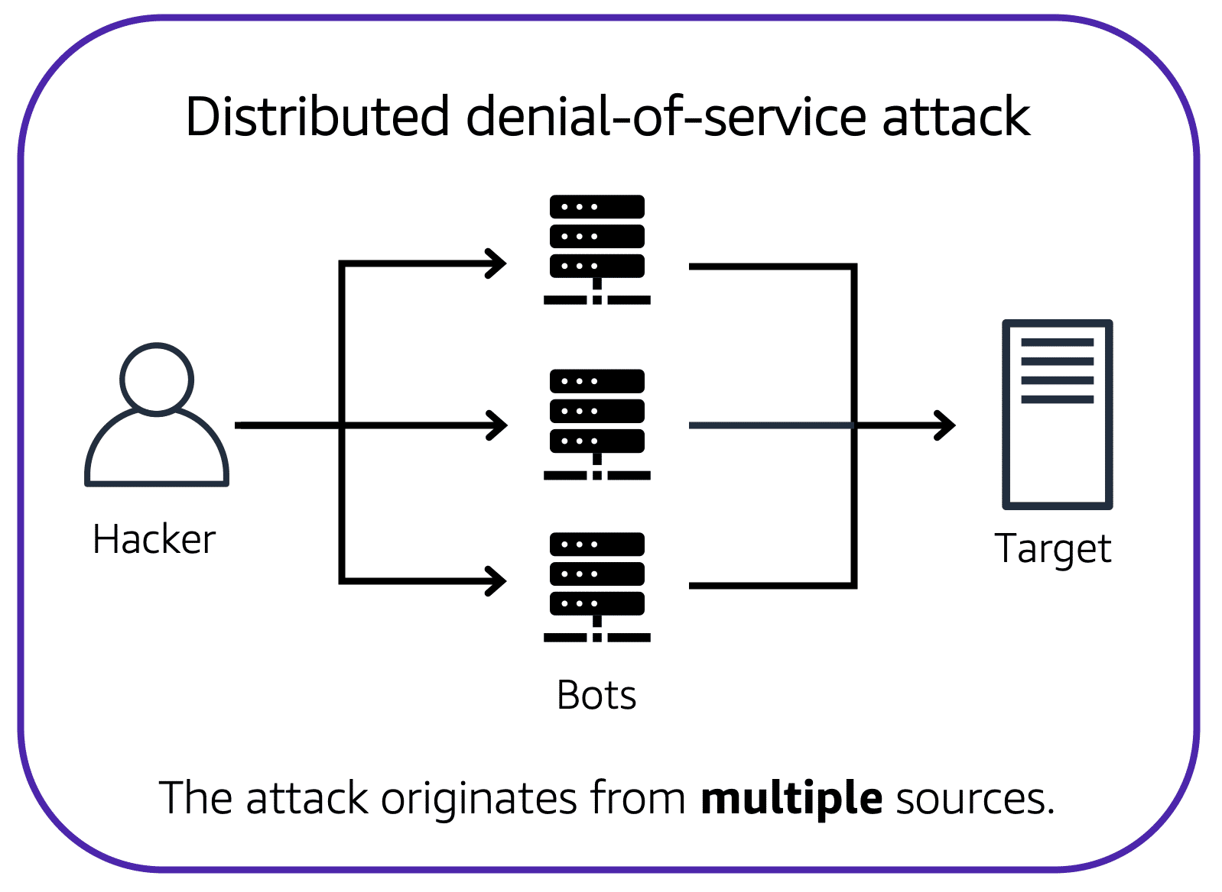Now, suppose that the prankster has enlisted the help of friends.

The prankster and their friends repeatedly call the coffee shop with requests to place orders, even though they do not intend to pick them up. These requests are coming in from different phone numbers, and it’s impossible for the coffee shop to block them all. Additionally, the influx of calls has made it increasingly difficult for customers to be able to get their calls through. This is similar to a **distributed denial-of-service attack**.

In a distributed denial-of-service (DDoS) attack, multiple sources are used to start an attack that aims to make a website or application unavailable. This can come from a group of attackers, or even a single attacker. The single attacker can use multiple infected computers (also known as “bots”) to send excessive traffic to a website or application.

To help minimize the effect of DoS and DDoS attacks on your applications, you can use [**AWS Shield**](https://aws.amazon.com/shield).

**3) AWS Shield**

AWS Shield is a service that protects applications against DDoS attacks. AWS Shield provides two levels of protection: Standard and Advanced. To learn more about AWS Shield, expand each of the following two categories.

**3-1) AWS Shield Standard**

**AWS Shield Standard** automatically protects all AWS customers **at no cost**. It protects your AWS resources from the most common, frequently occurring types of DDoS attacks.

As network traffic comes into your applications, AWS Shield Standard uses a variety of analysis techniques to **detect malicious traffic in real time and automatically mitigates it**.

**3-2) AWS Shield Advanced**

**AWS Shield Advanced** is a paid service that provides **detailed attack diagnostics** and the ability to detect and mitigate sophisticated DDoS attacks.

It also integrates with other services such as Amazon CloudFront, Amazon Route 53, and Elastic Load Balancing. Additionally, you can integrate AWS Shield with AWS WAF by writing custom rules to mitigate complex DDoS attacks.

# 6-6 Additional Security Services

**1) AWS Key Management Service (AWS KMS)**

The coffee shop has many items, such as coffee machines, pastries, money in the cash registers, and so on. You can think of these items as data. The coffee shop owners want to ensure that all of these items are secure, whether they’re sitting in the storage room or being transported between shop locations.

In the same way, you must ensure that your applications’ data is secure while in storage **(encryption at rest)** and while it is transmitted, known as **encryption in transit**.

[**AWS Key Management Service (AWS KMS)**](https://aws.amazon.com/kms) enables you to perform encryption operations through the use of **cryptographic keys**. A cryptographic key is a **random string of digits** used for locking (encrypting) and unlocking (decrypting) data. You can use AWS KMS to create, manage, and use **cryptographic keys**. You can also control the use of keys across a wide range of services and in your applications.

With AWS KMS, you can choose the specific levels of access control that you need for your keys. For example, you can specify which IAM users and roles are able to manage keys. Alternatively, you can temporarily disable keys so that they are no longer in use by anyone. Your keys never leave AWS KMS, and you are always in control of them.

**2) AWS WAF**

[**AWS WAF**](https://aws.amazon.com/waf) is a **web application firewall** that lets you monitor network requests that come into your web applications.

**AWS WAF works together with Amazon CloudFront and an Application Load Balancer**. Recall the **network access control lists** that you learned about in an earlier module. AWS WAF works in a similar way to **block or allow traffic**. However, it does this by using a [**web access control list (ACL)**](https://docs.aws.amazon.com/waf/latest/developerguide/web-acl.html)  to protect your AWS resources.

However, if a request comes from one of **the blocked IP addresses** that you have specified in the web ACL, AWS WAF denies access.

**3) Amazon Inspector (pin test)**

Suppose that the developers at the coffee shop are developing and testing a new ordering application. They want to make sure that they are designing the application in accordance with security best practices. However, they have several other applications to develop, so they cannot spend much time conducting manual assessments. **To perform automated security assessments**, they decide to use [**Amazon Inspector**](https://aws.amazon.com/inspector/).

Amazon Inspector helps to improve the security and compliance of applications by running automated security assessments. It checks applications for security vulnerabilities and deviations from security best practices, such as open access to Amazon EC2 instances and installations of vulnerable software versions.

After Amazon Inspector has performed an assessment, it provides you with a list of security findings. The list prioritizes by severity level, including a detailed description of each security issue and a recommendation for how to fix it. However, AWS does not guarantee that following the provided recommendations resolves every potential security issue. Under the shared responsibility model, customers are responsible for the security of their applications, processes, and tools that run on AWS services.

**4) Amazon GuardDuty**

[**Amazon GuardDuty**](https://aws.amazon.com/guardduty) is a service that provides **intelligent threat detection** for your AWS infrastructure and resources. It identifies threats by continuously **monitoring the network activity and account behavior** within your AWS environment.

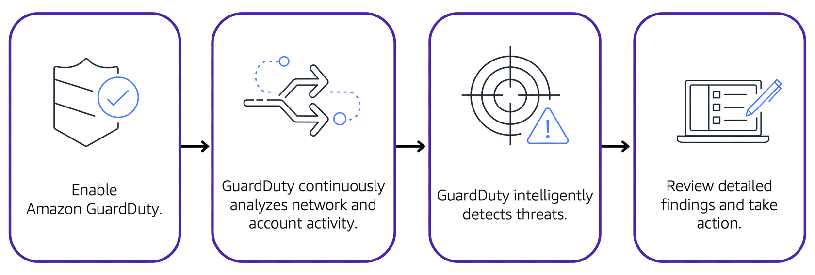

After you have enabled GuardDuty for your AWS account, GuardDuty begins monitoring your network and account activity. You do not have to deploy or manage any additional security software. GuardDuty then continuously analyzes data from multiple AWS sources, including **VPC Flow Logs and DNS logs**.

If GuardDuty detects any threats, you can review detailed findings about them **from the AWS Management Console**. Findings include recommended steps for remediation. You can also **configure AWS Lambda functions** to take remediation steps automatically in response to GuardDuty’s security findings.

# Module 7 Monitoring and Analytics

# 7-1. Amazon CloudWatch

**1) Amazon CloudWatch**

[**Amazon CloudWatch**](https://aws.amazon.com/cloudwatch/) is a web service that enables you to monitor and manage various metrics and configure alarm actions based on data from those metrics.

CloudWatch uses [**metrics**](https://docs.aws.amazon.com/AmazonCloudWatch/latest/monitoring/working_with_metrics.html) to represent the **data points** for your resources. AWS services send metrics to CloudWatch. CloudWatch then uses these metrics to create graphs automatically that **show how performance has changed over time**.

**2) CloudWatch alarms**

With CloudWatch, you can create [**alarms**](https://docs.aws.amazon.com/AmazonCloudWatch/latest/monitoring/AlarmThatSendsEmail.html) that automatically perform actions if the value of your metric has gone above or below a predefined threshold.

For example, suppose that your company’s developers use Amazon EC2 instances for application development or testing purposes. If the developers occasionally forget to stop the instances, the instances will continue to run and incur charges.

In this scenario, you could create a CloudWatch alarm that automatically stops an Amazon EC2 instance when the CPU utilization percentage has remained below a certain threshold for a specified period. When configuring the alarm, you can specify to receive a notification whenever this alarm is triggered.

**3) CloudWatch dashboard**

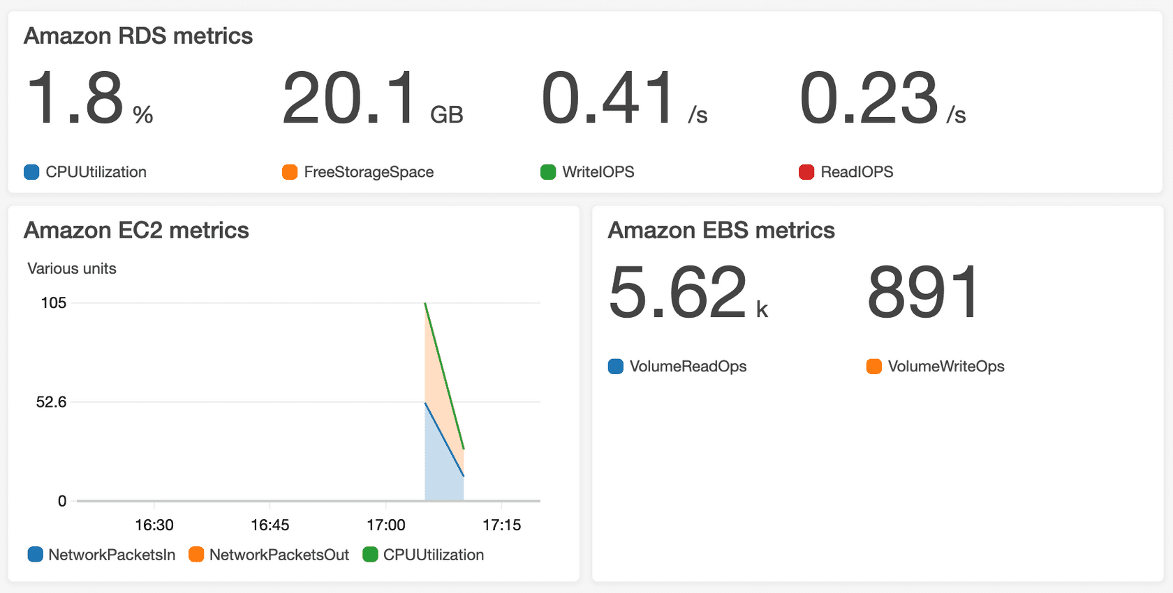

The CloudWatch [**dashboard**](https://docs.aws.amazon.com/AmazonCloudWatch/latest/monitoring/CloudWatch_Dashboards.html) feature enables you to access all the metrics for your resources from a single location. For example, you can use a CloudWatch dashboard to monitor the CPU utilization of an Amazon EC2 instance, the total number of requests made to an Amazon S3 bucket, and more. You can even customize separate dashboards for different business purposes, applications, or resources.

# 7-2. AWS CloudTrail

**1) AWS CloudTrail**

[**AWS CloudTrail**](https://aws.amazon.com/cloudtrail/) **records API calls** for your account. The recorded information includes the identity of the API caller, the time of the API call, the source IP address of the API caller, and more. You can think of CloudTrail as a “trail” of breadcrumbs (or **a log of actions**) that someone has left behind them.

Recall that you can use API calls to provision, manage, and configure your AWS resources. With CloudTrail, **you can view a complete history of user activity and API calls** for your applications and resources.

Events are typically updated in CloudTrail within **15 minutes** after an API call. You can filter events by specifying the time and date that an API call occurred, the user who requested the action, the type of resource that was involved in the API call, and more.

**Example: AWS CloudTrail event**

Suppose that the coffee shop owner is browsing through the AWS Identity and Access Management (IAM) section of the AWS Management Console. They discover that a new IAM user named Mary was created, but they do not know who, when, or which method created the user.

To answer these questions, the owner navigates to AWS CloudTrail.

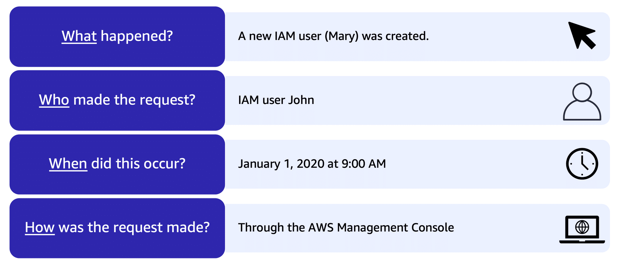

In the CloudTrail Event History section, the owner applies a filter to display only the events for the “CreateUser” API action in IAM. The owner locates the event for the API call that created an IAM user for Mary. This event record provides complete details about what occurred:

On January 1, 2020 at 9:00 AM, IAM user John created a new IAM user (Mary) through the AWS Management Console.

**CloudTrail Insights**

Within CloudTrail, you can also enable [**CloudTrail Insights**](https://docs.aws.amazon.com/awscloudtrail/latest/userguide/logging-insights-events-with-cloudtrail.html). **This optional feature allows CloudTrail to automatically detect unusual API activities in your AWS account.**

For example, CloudTrail Insights might detect that a higher number of Amazon EC2 instances than usual have recently launched in your account. You can then review the full event details to determine which actions you need to take next.

# 7-3. AWS Trusted Advisor

**1) AWS Trusted Advisor**

[**AWS Trusted Advisor**](https://aws.amazon.com/premiumsupport/technology/trusted-advisor/) is a **web service that inspects your AWS environment and provides real-time recommendations** in accordance with AWS best practices.

Trusted Advisor compares its findings to AWS best practices in five categories: **cost optimization, performance, security, fault tolerance, and service limits**. For the checks in each category, Trusted Advisor offers a list of recommended actions and additional resources to learn more about AWS best practices.

The guidance provided by AWS Trusted Advisor can benefit your company at all stages of deployment. For example, you can use AWS Trusted Advisor to assist you while you are creating new workflows and developing new applications. You can also use it while you are making ongoing improvements to existing applications and resources.

**2) AWS Trusted Advisor dashboard**

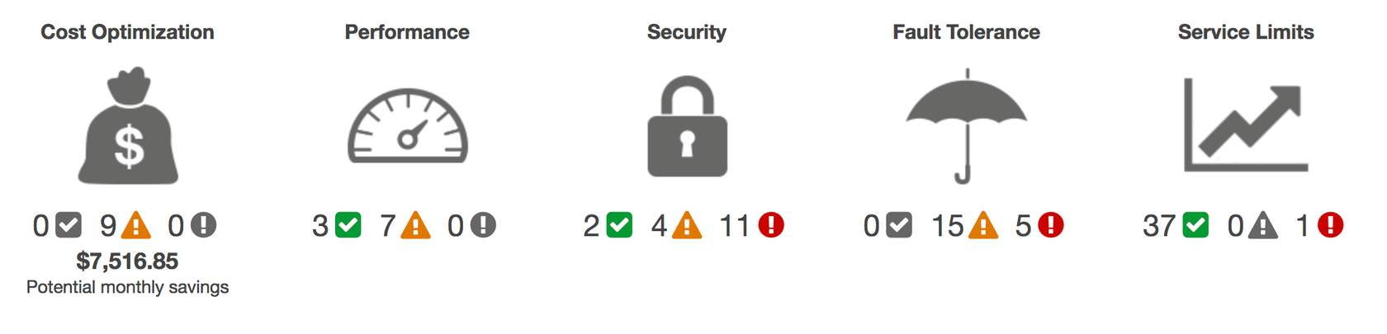

When you access the Trusted Advisor dashboard on the AWS Management Console, you can review completed checks for cost optimization, performance, security, fault tolerance, and service limits.

For each category:

* The green check indicates the number of items for which it detected **no problems**.
* The orange triangle represents the number of recommended **investigations**.
* The red circle represents the number of recommended **actions**.

Q1) Which actions can you perform using Amazon CloudWatch? (Select TWO.)

* Monitor your resources’ utilization and performance  🡺 CloudWatch
* Receive real-time guidance for improving your AWS environment 🡺 Trusted Advisor
* Compare your infrastructure to AWS best practices in five categories 🡺 Trusted Advisor
* Access metrics from a single dashboard 🡺 CloudWatch
* Automatically detect unusual account activity 🡺 CloudTrail

Q2) Which service enables you to review the security of your Amazon S3 buckets by checking for open access permissions?

* Amazon CloudWatch
* AWS CloudTrail
* AWS Trusted Advisor
* Amazon GuardDuty

# AWS Trusted Advisor is a web service that inspects your AWS environment and provides real-time recommendations in accordance with AWS best practices. The inspection includes security checks, such as Amazon S3 buckets with open access permissions.

# Module 8 Pricing and Support

# 8-1. AWS Free Tier

**1) Always Free**

These offers do not expire and are available to all AWS customers.

For example, AWS Lambda allows 1 million free requests and up to 3.2 million seconds of compute time per month. Amazon DynamoDB allows 25 GB of free storage per month.

**2) 12 Months Free**

These offers are free for 12 months following your initial sign-up date to AWS.

Examples include specific amounts of Amazon S3 Standard Storage, thresholds for monthly hours of Amazon EC2 compute time, and amounts of Amazon CloudFront data transfer out.

**3) Trials**

Short-term free trial offers start from the date you activate a particular service. The length of each trial might vary by number of days or the amount of usage in the service.

For example, Amazon Inspector offers a 90-day free trial. Amazon Lightsail (a service that enables you to run virtual private servers) offers 750 free hours of usage over a 30-day period.

# 8-2. AWS Pricing Concepts

**1) How AWS pricing works**

**Pay for what you use.**

For each service, you pay for exactly the amount of resources that you actually use, without requiring long-term contracts or complex licensing.

**Pay less when you reserve.**

Some services offer reservation options that provide a significant discount compared to On-Demand Instance pricing.

For example, suppose that your company is using Amazon EC2 instances for a workload that needs to run continuously. You might choose to run this workload on Amazon EC2 Instance Savings Plans, because the plan allows you to save up to 72% over the equivalent On-Demand Instance capacity.

**Pay less with volume-based discounts when you use more.**

Some services offer tiered pricing, so the per-unit cost is incrementally lower with increased usage.

For example, the more Amazon S3 storage space you use, the less you pay for it per GB.

**2) AWS Pricing Calculator**

The [**AWS Pricing Calculator**](https://calculator.aws/#/) lets you explore AWS services and create an **estimate for the cost of your use cases on AWS**. You can organize your AWS estimates by groups that you define. A group can reflect how your company is organized, such as providing estimates by cost center.

When you have created an estimate, you can save it and generate a link to share it with others.

Suppose that your company is interested in using Amazon EC2. However, you are not yet sure which AWS Region or instance type would be the most cost-efficient for your use case. In the AWS Pricing Calculator, you can enter details, such as the kind of operating system you need, memory requirements, and input/output (I/O) requirements. By using the AWS Pricing Calculator, you can review an estimated **comparison of different EC2 instance types across AWS Regions**.

**3) AWS pricing examples**

**3-1) AWS Lambda**

**AWS LAMBDA PRICING**

For AWS Lambda, you are charged based on the **number of requests for your functions and the time** that it takes for them to run.

AWS Lambda allows **1 million free requests** and up to **3.2 million seconds of compute time per month**.

You can save on AWS Lambda costs by signing up for a Compute Savings Plan. A Compute Savings Plan offers lower compute costs in exchange for committing to a consistent amount of usage over a 1-year or 3-year term. This is an example of **paying less when you reserve**.

**3-2) Amazon EC2**

**AMAZON EC2 PRICING**

With Amazon EC2, you pay for **only the compute time** that you use while your instances are running.

For some workloads, you can significantly reduce Amazon EC2 costs by using Spot Instances. For example, suppose that you are running a batch processing job that is able to withstand interruptions. Using a Spot Instance would provide you with up to 90% cost savings while still meeting the availability requirements of your workload.

You can find additional cost savings for Amazon EC2 by considering Savings Plans and Reserved Instances.

# PRICING EXAMPLE

Take an Amazon EC2 instance that has been deployed in the Northern Virginia Region for example. The service charges include details for the following items:

* One Amazon EC2 instance that has been running for about 107 hours
* Roughly 11 GB of Amazon EBS storage space that has been provisioned in the month
* An Application Load Balancer that has been used for 268 hours

In this example, all the usage amounts are under the thresholds in the AWS Free Tier, so the account owner would not have to pay for any Amazon EC2 usage in this month.

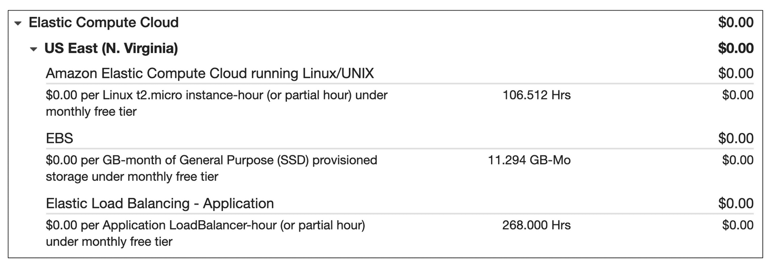

**3-3) Amazon S3**

**AMAZON S3 PRICING**

For Amazon S3 pricing, consider the following cost components:

* **Storage - You pay for only the storage that you use**. You are charged the rate to store objects in your Amazon S3 buckets based on your objects’ sizes, storage classes, and how long you have stored each object during the month.
* **Requests and data retrievals -**You pay for requests made to your Amazon S3 objects and buckets. For example, suppose that you are storing photo files in Amazon S3 buckets and hosting them on a website. Every time a visitor **requests** the website that includes these photo files, this counts towards requests you must pay for.
* **Data transfer - There is no cost to transfer data between different Amazon S3 buckets or from Amazon S3 to other services within the same AWS Region. However, you pay for data that you transfer into and out of Amazon S3**, with a few exceptions. There is no cost for data transferred into Amazon S3 from the **internet or out to Amazon CloudFront**. There is also no cost for data transferred out to an **Amazon EC2 instance in the same AWS Region** as the Amazon S3 bucket.
* **Management and replication -** You pay for the **storage management features** that you have enabled on your account’s Amazon S3 buckets. These features include **Amazon S3 inventory, analytics, and object tagging.**

**PRICING EXAMPLE**

Let's look at an AWS account that has used Amazon S3 in two Regions: Northern Virginia and Ohio.For each Region, itemized charges are based on the following factors:

* The number of requests to add or copy objects into a bucket. More specifically, these commands are also known as PUT, COPY, POST or LIST.
* The number of requests to retrieve objects from a bucket. This command is also known as GET.
* The amount of storage space used.

The Northern Virginia Region has two tiers of Amazon S3: Tier 1 and Tier 2.

* In Tier 1, there were 185 requests to add or copy objects into a bucket. (There were no requests to retrieve objects from a bucket.) 0.159 GB of storage space was used.
* In Tier 2, there were 923 requests to retrieve objects from a bucket. (There were no requests to add or copy objects to a bucket.)

The Ohio Region has one tier of Amazon S3: Tier 2. There were four requests to retrieve objects from a bucket and 0.000001 GB of storage space was used. There were no requests to add or copy objects to a bucket.

All the usage for Amazon S3 in this example is under the AWS Free Tier limits, so the account owner would not have to pay for any Amazon S3 usage in this month.

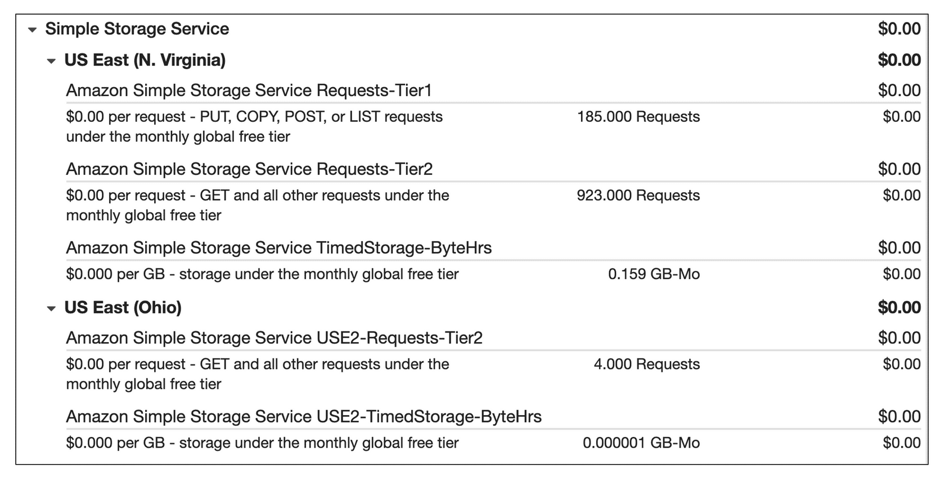

# 8-3. Billing Dashboard

Use the [**AWS Billing & Cost Management dashboard**](https://docs.aws.amazon.com/awsaccountbilling/latest/aboutv2/billing-what-is.html) to pay your AWS bill, monitor your usage, and analyze and control your costs.

* Compare your current month-to-date balance with the previous month, and get a forecast of the next month based on current usage.
* View month-to-date spend by service.
* View Free Tier usage by service.
* Access Cost Explorer and create budgets.
* Purchase and manage Savings Plans.
* Publish [AWS Cost and Usage Reports](https://docs.aws.amazon.com/cur/latest/userguide/what-is-cur.html).

# 8-4. Consolidated Billing

In an earlier module, you learned about AWS Organizations, a service that enables you to manage multiple AWS accounts from a central location. AWS Organizations also provides the option for [**consolidated billing**](https://docs.aws.amazon.com/awsaccountbilling/latest/aboutv2/consolidated-billing.html).

The consolidated billing feature of AWS Organizations **enables you to receive a single bill for all AWS accounts in your organization.** By consolidating, you can easily track the combined costs of all the linked accounts in your organization. The default maximum number of accounts allowed for an organization is 4, but you can contact AWS Support to increase your quota, if needed.

On your monthly bill, you can review itemized charges incurred by each account. This enables you to have greater transparency into your organization’s accounts while still maintaining the convenience of receiving a single monthly bill.

Another benefit of consolidated billing is the ability to share bulk discount pricing, Savings Plans, and Reserved Instances across the accounts in your organization. For instance, one account might not have enough monthly usage to qualify for discount pricing. However, when multiple accounts are combined, their aggregated usage may result in a benefit that applies across all accounts in the organization.

To review and example of consolidated billing, choose the arrow buttons to display the four steps.

# 8-5. AWS Budgets

**AWS Budgets**

In [**AWS Budgets**](https://aws.amazon.com/aws-cost-management/aws-budgets), you can create budgets to plan your service usage, service costs, and instance reservations.

The information in AWS Budgets updates **three times a day**. This helps you to accurately determine how close your usage is to your budgeted amounts or to the AWS Free Tier limits.

In AWS Budgets, you can also **set custom alerts when your usage exceeds** (or is forecasted to exceed) the budgeted amount.

**Example: AWS Budgets**

Suppose that you have set a budget for Amazon EC2. You want to ensure that your company’s usage of Amazon EC2 does not exceed $200 for the month.

In AWS Budgets, you could set a custom budget to notify you when your usage has reached half of this amount ($100). This setting would allow you to receive an alert and decide how you would like to proceed with your continued use of Amazon EC2.

To learn more about AWS Budgets, choose each of the numbered markers.

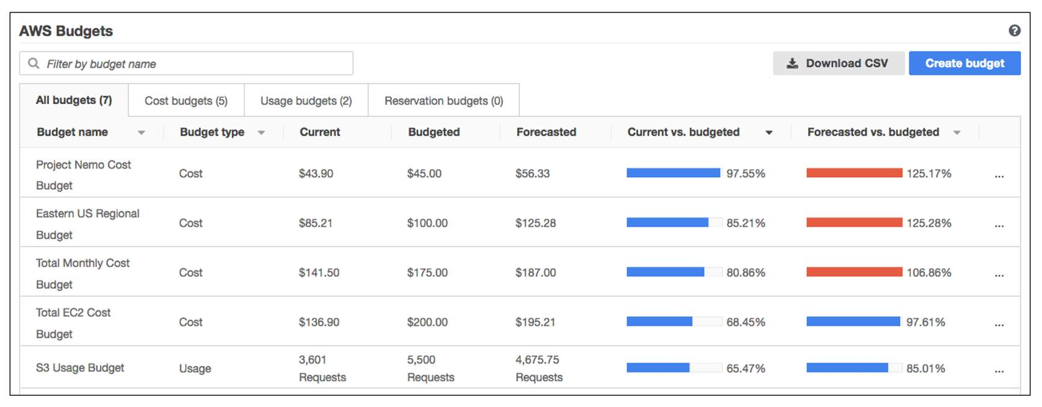

# 8-6. AWS Cost Explorer

**AWS Cost Explorer**

[**AWS Cost Explorer**](https://aws.amazon.com/aws-cost-management/aws-cost-explorer/) is a tool that lets you **visualize**, understand, and manage your AWS costs and usage over time.

AWS Cost Explorer includes a default **report of the costs and usage for your top five cost**-accruing AWS services. You can apply custom filters and groups to analyze your data. For example, **you can view resource usage at the hourly level.**

**Example: AWS Cost Explorer**

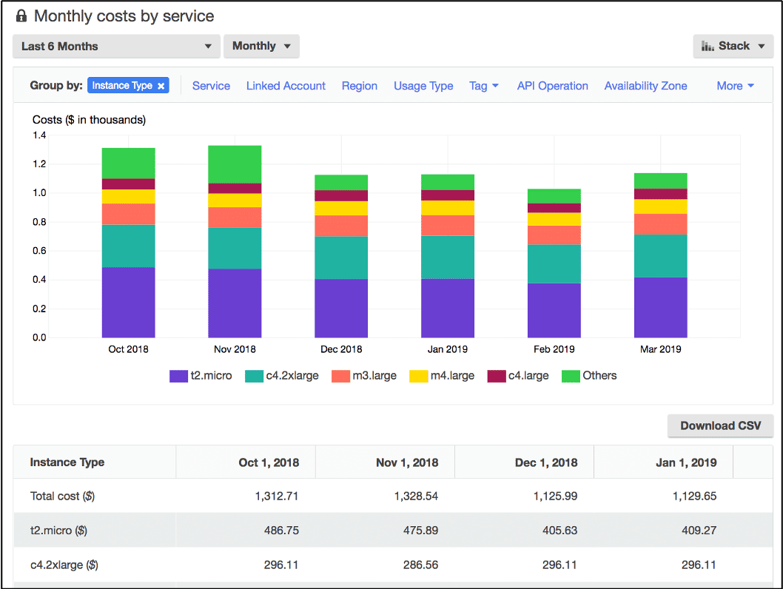

This example of the AWS Cost Explorer dashboard displays monthly costs for Amazon EC2 instances over a 6-month period. The bar for each month separates the costs for **different Amazon EC2 instance types**, such as t2.micro or m3.large.

By analyzing your AWS costs over time, you can make informed decisions about future costs and how to plan your budgets.

# 8-7. AWS Support Plans

**1) AWS Support**

AWS offers four different [**Support plans**](https://aws.amazon.com/premiumsupport/plans/) to help you troubleshoot issues, lower costs, and efficiently use AWS services.

You can choose from the following Support plans to meet your company’s needs:

* Basic
* Developer
* Business
* Enterprise On-Ramp
* Enterprise

**1-1) Basic Support**

**Basic Support** is free for all AWS customers. It includes access to whitepapers, documentation, and support communities. With Basic Support, you can also contact AWS for billing questions and service limit increases.

With Basic Support, you have access to a limited selection of AWS Trusted Advisor checks. Additionally, you can use the **AWS Personal Health Dashboard**, a tool that provides alerts and remediation guidance when AWS is experiencing events that may affect you.

If your company needs support beyond the Basic level, you could consider purchasing Developer, Business, Enterprise On-Ramp, and Enterprise Support.

**1-2) Developer Support**

Customers in the **Developer Support** plan have access to features such as:

* Best practice guidance
* Client-side diagnostic tools
* Building-block architecture support, which consists of guidance for how to use AWS offerings, features, and services together

For example, suppose that your company is exploring AWS services. You’ve heard about a few different AWS services. However, you’re unsure of how to potentially use them together to build applications that can address your company’s needs. In this scenario, the building-block architecture support that is included with the Developer Support plan could help you to identify opportunities for combining specific services and features.

**1-3) Business Support**

Customers with a **Business Support** plan have access to additional features, including:

* Use-case guidance to identify AWS offerings, features, and services that can best support your specific needs
* **All AWS Trusted Advisor checks**
* Limited support for third-party software, such as common operating systems and application stack components

Suppose that your company has the Business Support plan and wants to install a common third-party operating system onto your Amazon EC2 instances. You could contact **AWS Support for assistance** with installing, configuring, and troubleshooting the operating system. For advanced topics such as optimizing performance, using custom scripts, or resolving security issues, you may need to contact the third-party software provider directly.

**1-4) Enterprise On-Ramp Support**

In November 2021, AWS opened enrollment into AWS Enterprise On-Ramp Support plan. In addition to all the features included in the Basic, Developer, and Business Support plans, customers with an Enterprise On-Ramp Support plan have access to:

* A pool of Technical Account Managers to provide proactive guidance and coordinate access to programs and AWS experts
* A Cost Optimization workshop (one per year)
* A Concierge support team for billing and account assistance
* Tools to monitor costs and performance through Trusted Advisor and Health API/Dashboard

Enterprise On-Ramp Support plan also provides access to a specific set of proactive support services, which are provided by a pool of Technical Account Managers.

* Consultative review and architecture guidance (one per year)
* Infrastructure Event Management support (one per year)
* Support automation workflows
* 30 minutes or less response time for business-critical issues

**1-5) Enterprise Support**

In addition to all features included in the Basic, Developer, Business, and Enterprise On-Ramp support plans, customers with Enterprise Support have access to:

* A designated Technical Account Manager to provide proactive guidance and coordinate access to programs and AWS experts
* A Concierge support team for billing and account assistance
* Operations Reviews and tools to monitor health
* Training and Game Days to drive innovation
* Tools to monitor costs and performance through Trusted Advisor and Health API/Dashboard

The Enterprise plan also provides full access to proactive services, which are provided by a designated Technical Account Manager:

* Consultative review and architecture guidance
* Infrastructure Event Management support
* Cost Optimization Workshop and tools
* Support automation workflows
* 15 minutes or less response time for business-critical issues

**# Developer, Business, Enterprise On-Ramp, and Enterprise Support**

The Developer, Business, Enterprise On-Ramp, and Enterprise Support plans include all the benefits of Basic Support, in addition to the ability to open an unrestricted number of technical support cases. These Support plans have pay-by-the-month pricing and require no long-term contracts.  
  
In general, for pricing, the Developer plan has the lowest cost, the Business and Enterprise On-Ramp plans are in the middle, and the Enterprise plan has the highest cost.

**2) Technical Account Manager (TAM)**

The **Enterprise On-Ramp and Enterprise Support plans include** access to a **Technical Account Manager (TAM)**.  
  
The TAM is your primary point of contact at AWS. If your company subscribes to Enterprise Support or Enterprise On-Ramp, your TAM educates, empowers, and evolves your cloud journey across the full range of AWS services. TAMs provide expert engineering guidance, help you design solutions that efficiently integrate AWS services, assist with cost-effective and resilient architectures, and provide direct access to AWS programs and a broad community of experts.  
  
For example, suppose that you are interested in developing an application that uses several AWS services together. Your TAM could provide insights into how to best use the services together. They achieve this, while aligning with the specific needs that your company is hoping to address through the new application.

# 8-8. AWS Marketplace

[**AWS Marketplace**](https://aws.amazon.com/marketplace) is a digital catalog that includes thousands of software listings from independent software vendors. You can use AWS Marketplace to find, test, and buy software that runs on AWS.

For each listing in AWS Marketplace, you can access detailed information on pricing options, available support, and reviews from other AWS customers.

You can also explore software solutions by industry and use case. For example, suppose your company is in the healthcare industry. In AWS Marketplace, you can review use cases that software helps you to address, such as implementing solutions to protect patient records or using machine learning models to analyze a patient’s medical history and predict possible health risks.

**AWS Marketplace categories**

AWS Marketplace offers products in several categories, such as Infrastructure Software, DevOps, Data Products, Professional Services, Business Applications, Machine Learning, Industries, and Internet of Things (IoT).

Within each category, you can narrow your search by browsing through product listings in subcategories. For example, subcategories in the DevOps category include areas such as Application Development, Monitoring, and Testing.

# Module 9 Migration and Innovation

# 9-1. AWS Cloud Adoption Framework (AWS CAF)

**Six core perspectives of the Cloud Adoption Framework**

At the highest level, the [**AWS Cloud Adoption Framework (AWS CAF)**](https://d1.awsstatic.com/whitepapers/aws_cloud_adoption_framework.pdf) organizes guidance into six areas of focus, called **Perspectives**. Each Perspective addresses distinct responsibilities. The planning process helps the right people across the organization prepare for the changes ahead.

In general, the **Business**, **People**, and **Governance** Perspectives focus on **business capabilities**, whereas the **Platform**, **Security**, and **Operations** Perspectives focus on **technical capabilities**.

**1) Business Perspective**

The **Business Perspective** ensures that IT aligns with **business needs** and that IT investments link to key business results. Use the Business Perspective to create a strong business case for cloud adoption and prioritize cloud adoption initiatives. Ensure that your business strategies and goals align with your IT strategies and goals.

Common roles in the Business Perspective include:

* Business managers
* Finance managers
* Budget owners
* Strategy stakeholders

**2) People Perspective**

The **People Perspective** supports development of an organization-wide change management strategy for successful cloud adoption. Use the People Perspective to evaluate organizational structures and roles, new skill and process requirements, and identify gaps. This helps prioritize training, staffing, and organizational changes.

Common roles in the People Perspective include:

* Human resources
* Staffing
* People managers

**3) Governance Perspective**

The **Governance Perspective** focuses on the skills and processes to align IT strategy with business strategy. This ensures that you maximize the business value and minimize risks. Use the Governance Perspective to understand how to update the staff skills and processes necessary to ensure business governance in the cloud. Manage and measure cloud investments to evaluate business outcomes.

Common roles in the Governance Perspective include:

* Chief Information Officer (CIO)
* Program managers
* Enterprise architects
* Business analysts
* Portfolio managers

**4) Platform Perspective**

The **Platform Perspective** includes principles and patterns for implementing new solutions on the cloud and migrating on-premises workloads to the cloud. Use a variety of architectural models to understand and communicate the structure of IT systems and their relationships. Describe the architecture of the target state environment in detail.

Common roles in the Platform Perspective include:

* Chief Technology Officer (CTO)
* IT managers
* Solutions architects

**5) Security Perspective**

The **Security Perspective** ensures that the organization meets security objectives for visibility, auditability, control, and agility. Use the AWS CAF to structure the selection and implementation of security controls that meet the organization’s needs.

Common roles in the Security Perspective include:

* Chief Information Security Officer (CISO)
* IT security managers
* IT security analysts

**6) Operations Perspective**

The **Operations Perspective** helps you to enable, run, use, operate, and recover IT workloads to the level agreed upon with your business stakeholders. Define how day-to-day, quarter-to-quarter, and year-to-year business is conducted. Align with and support the operations of the business. The AWS CAF helps these stakeholders define current operating procedures and identify the process changes and training needed to implement successful cloud adoption.

Common roles in the Operations Perspective include:

* IT operations managers
* IT support managers

# Q) Which Perspective of the AWS Cloud Adoption Framework helps you design, implement, and optimize your AWS infrastructure based on your business goals and perspectives?

The Platform Perspective of the AWS Cloud Adoption Framework also includes principles for implementing new solutions and migrating on-premises workloads to the cloud.

**Q) Which Perspective of the AWS Cloud Adoption Framework helps you structure the selection and implementation of permissions?**

The Security Perspective of the AWS Cloud Adoption Framework also helps you to identify areas on non-compliance and plan ongoing security initiatives.

**9-2. 6 strategies for migration**

When migrating applications to the cloud, six of the most common [migration strategies(opens in a new tab)](https://aws.amazon.com/blogs/enterprise-strategy/6-strategies-for-migrating-applications-to-the-cloud/) that you can implement are:

**1) Rehosting**

**Rehosting** also known as “lift-and-shift” involves moving applications **without changes**.

In the scenario of a large legacy migration, in which the company is looking to implement its migration and scale quickly to meet a business case, the majority of applications are rehosted.

**2) Replatforming**

**Replatforming**, also known as “lift, tinker, and shift,” involves **making a few cloud optimizations to realize a tangible benefit**. Optimization is achieved without changing the core architecture of the application.

**3) Refactoring/re-architecting**

**Refactoring** (also known as **re-architecting**) involves **reimagining how an application is architected and developed by using cloud-native features**. Refactoring is driven by a strong business need to add features, scale, or performance that would otherwise be difficult to achieve in the application’s existing environment.

**4) Repurchasing**

**Repurchasing** involves moving from a traditional license to a **software-as-a-service model**. For example, a business might choose to implement the repurchasing strategy by migrating from a customer relationship management (CRM) system to Salesforce.com.

**5) Retaining**

**Retaining** consists of keeping applications that are critical for the business in the source environment. This might include applications that require major refactoring before they can be migrated, or, work that can be postponed until a later time.

**6) Retiring**

**Retiring** is the process of removing applications that are no longer needed.

**Q) Which migration strategy involves moving to a different product?**

Repurchasing involves replacing an existing application with a cloud-based version, such as software found in AWS Marketplace.

# 9-3. AWS Snow Family

**AWS Snow Family members**

The [**AWS Snow Family**](https://aws.amazon.com/snow) is a collection of physical devices that help to physically transport up to exabytes of data into and out of AWS.

AWS Snow Family is composed of **AWS Snowcone**, **AWS Snowball**, and **AWS Snowmobile**.

These devices offer different capacity points, and most include built-in computing capabilities. AWS owns and manages the Snow Family devices and integrates with AWS security, monitoring, storage management, and computing capabilities.

**1) AWS SNOWCONEAWS**

[**AWS Snowcone**](https://aws.amazon.com/snowcone) is a small, rugged, and secure edge computing and data transfer device.

It features **2 CPUs, 4 GB of memory**, and up to **14 TB of usable storage**.

**2) SNOWBALLAWS**

[**AWS Snowball**](https://aws.amazon.com/snowball/) offers two types of devices:

* **Snowball Edge Storage Optimized**devices are well suited for large-scale data migrations and recurring transfer workflows, in addition to local computing with higher capacity needs.
  + Storage: **80 TB of hard disk** drive (HDD) capacity for block volumes and Amazon S3 compatible object storage, and **1 TB of SATA solid state drive** (SSD) for block volumes.
  + Compute: **40 vCPUs, and 80 GiB of memory** to support Amazon EC2 sbe1 instances (equivalent to C5).
* **Snowball Edge Compute Optimized**provides powerful computing resources for use cases such as machine learning, full motion video analysis, analytics, and local computing stacks.
  + Storage: 80-TB usable HDD capacity for Amazon S3 compatible object storage or Amazon EBS compatible block volumes and **28 TB of usable NVMe SSD capacity for** Amazon EBS compatible block volumes.
  + Compute: **104 vCPUs, 416 GiB** of memory, and an optional NVIDIA Tesla V100 GPU. Devices run Amazon EC2 sbe-c and sbe-g instances, which are equivalent to C5, M5a, G3, and P3 instances.

**3) SNOWMOBILE**

[**AWS Snowmobile**](https://aws.amazon.com/snowmobile) is an **exabyte-scale data transfer service** used to move large amounts of data to AWS. You can transfer up to **100 petabytes of data** per Snowmobile, a 45-foot long ruggedized shipping container, pulled by a semi-trailer truck.

**Q) What is the storage capacity of Snowball Edge Storage Optimized?**

The correct response option is **80 TB**.

# 9-4. Innovation with AWS

**9-1) Innovate with AWS Services**

When examining how to use AWS services, it is important to focus on the desired outcomes. You are properly equipped to drive innovation in the cloud if you can clearly articulate the following conditions:

* The current state
* The desired state
* The problems you are trying to solve

Consider some of the paths you might explore in the future as you continue on your cloud journey. To learn more on ways to innovate with AWS, expand each of the following three categories.

**1) Serverless applications**

With AWS, **serverless** refers to applications that don’t require you to provision, maintain, or administer servers. You don’t need to worry about fault tolerance or availability. AWS handles these capabilities for you.

AWS Lambda is an example of a service that you can use to run serverless applications. If you design your architecture to trigger Lambda functions to run your code, you can bypass the need to manage a fleet of servers. Building your architecture with serverless applications enables your developers to focus on their core product instead of managing and operating servers.

**2) Machine learning**

Traditional **machine learning (ML)** development is complex, expensive, time consuming, and error prone. AWS offers Amazon **SageMaker** to remove the difficult work from the process and empower you to build, train, and deploy ML models quickly. You can use ML to analyze data, solve complex problems, and predict outcomes before they happen.

**3) Artificial intelligence**

AWS offers a variety of services powered by **artificial intelligence (AI)**.

For example, you can perform the following tasks:

* Get code recommendations while writing code and identify security issues in your code with Amazon **CodeWhisperer**.
* Convert speech to text with Amazon **Transcribe**.
* Discover patterns in text with Amazon **Comprehend**.
* Identify potentially fraudulent online activities with **Amazon Fraud Detector**.
* Build voice and text chatbots with Amazon **Lex**.

**Amazon CodeWhisperer**

Amazon CodeWhisperer is an AI software coding companion. It analyzes code and comments as a developer writes code in their integrated development environment. It goes beyond code completion by using natural language processing to comprehend the comments in a developer's code. By understanding English comments, CodeWhisperer generates complete functions and code blocks that align with a developer's descriptions. Additionally, CodeWhisperer analyzes the surrounding code, ensuring the generated code matches a developer's style and naming conventions.

# Module 10 The Cloud Journey

# 10-1. The AWS Well-Architected Framework

The [**AWS Well-Architected Framework**](https://docs.aws.amazon.com/wellarchitected/latest/framework/welcome.html) helps you understand how to design and operate reliable, secure, efficient, and cost-effective systems in the AWS Cloud. It provides a way for you to consistently measure your architecture against best practices and design principles and identify areas for improvement. The Well-Architected Framework is based on six pillars:

**1) Operational excellence**

**Operational excellence** is the **ability to run** and **monitor systems to deliver business value** and to continually **improve supporting processes and procedures**.

Design principles for operational excellence in the cloud include performing operations as code, annotating documentation, anticipating failure, and frequently making small, reversible changes.

**2) Security**

The **Security** pillar is the ability to protect information, systems, and assets while delivering business value through risk assessments and mitigation strategies.

When considering the security of your architecture, apply these best practices:

* Automate security best practices when possible.
* Apply security at all layers.
* Protect data in transit and at rest.

**3) Reliability**

**Reliability** is the ability of a system to do the following:

* Recover from infrastructure or service disruptions
* Dynamically acquire computing resources to meet demand
* Mitigate disruptions such as misconfigurations or transient network issues

Reliability includes testing recovery procedures, scaling horizontally to increase aggregate system availability, and automatically recovering from failure.

**4) Performance efficiency**

**Performance efficiency** is the ability to use computing resources efficiently to meet system requirements and to maintain that efficiency as demand changes and technologies evolve.

Evaluating the performance efficiency of your architecture includes experimenting more often, using serverless architectures, and designing systems to be able to go global in minutes.

**5) Cost optimization**

**Cost optimization** is the ability to run systems to deliver business value at the lowest price point.

Cost optimization includes adopting a consumption model, analyzing and attributing expenditure, and using managed services to reduce the cost of ownership.

**6) Sustainability**

Sustainability is the ability to continually improve sustainability impacts by reducing energy consumption and increasing efficiency across all components of a workload by maximizing the benefits from the provisioned resources and minimizing the total resources required.

To facilitate good design for sustainability:

* Understand your impact
* Establish sustainability goals
* Maximize utilization
* Anticipate and adopt new, more efficient hardware and software offerings
* Use managed services
* Reduce the downstream impact of your cloud workloads

# 10-2. Benefits of the AWS Cloud

**Advantages of cloud computing**

Operating in the AWS Cloud offers many benefits over computing in on-premises or hybrid environments.

**1) Trade upfront expense for variable expense.**

Upfront expenses include data centers, physical servers, and other resources that you would need to invest in before using computing resources. Instead of investing heavily in data centers and servers before you know how you’re going to use them, you can pay only when you consume computing resources.

**2) Benefit from massive economies of scale.**

By using cloud computing, you can achieve a lower variable cost than you can get on your own.

Because usage from hundreds of thousands of customers aggregates in the cloud, providers such as AWS can achieve higher economies of scale. **Economies of scale translate into lower pay-as-you-go prices**.

**3) Stop guessing capacity.**

With cloud computing, you don’t have to predict how much infrastructure capacity you will need before deploying an application.  For example, you can launch Amazon Elastic Compute Cloud (Amazon EC2) instances when needed and pay only for the compute time you use. Instead of paying for resources that are unused or dealing with limited capacity, you can access only the capacity that you need, and scale in or out in response to demand.

**4) Increase speed and agility.**

The flexibility of cloud computing makes it easier for you to develop and deploy applications. This flexibility also provides your development teams with more time to experiment and innovate.

**5) Stop spending money running and maintaining data centers.**

Cloud computing in data centers often requires you to spend more money and time managing infrastructure and servers. A benefit of cloud computing is the ability to focus less on these tasks and more on your applications and customers.

6) **Go global in minutes.**

The AWS Cloud global footprint enables you to quickly deploy applications to customers around the world, while providing them with low latency.

# Q) Which process is an example of benefiting from massive economies of scale?

a. Deploying an application in multiple Regions around the world

b. Receiving lower pay-as-you-go prices as the result of AWS customers’ aggregated usage of services

c. Paying for compute time as you use it instead of investing upfront costs in data centers

d. Scaling your infrastructure capacity in and out to meet demand

# Q) Which pillar of the AWS Well-Architected Framework includes the ability to run workloads effectively and gain insights into their operations?

a. Cost Optimization

b. Operational Excellence

c. Performance Efficiency

d. Reliability

**Q) What are the benefits of cloud computing? (Select TWO.)**

a. Increase speed and agility.

b. Benefit from smaller economies of scale.

c. Trade variable expense for upfront expense.

d. Maintain infrastructure capacity.

e. Stop spending money running and maintaining data centers.

# Module 11 AWS Certified Cloud Practitioner Basics

| **Domain** | **Percentage of exam** |
| --- | --- |
| Domain 1: Cloud Concepts | 26% |
| Domain 2: Security and Compliance | 25% |
| Domain 3: Technology | 33% |
| Domain 4: Billing and Pricing | 16% |
| Total | 100% |